**Exercise 1: Employee Management System - Overview and Setup**

**EmployeeController.java**

package com.example.employeemanagementsystem.controller;

import com.example.employeemanagementsystem.model.Employee;

import com.example.employeemanagementsystem.repository.EmployeeRepository;

import org.springframework.beans.factory.annotation.Autowired;

import org.springframework.web.bind.annotation.*;

import java.util.List;

@RestController

@RequestMapping("/employees")

public class EmployeeController {

@Autowired

private EmployeeRepository repository;

@GetMapping

public List<Employee> getAll() {

return repository.findAll();

}

@PostMapping

public Employee create(@RequestBody Employee employee) {

return repository.save(employee);

}

}

**Employee.java**

package com.example.employeemanagementsystem.model;

import jakarta.persistence.*;

import lombok.*;

@Entity

@Data

@NoArgsConstructor

@AllArgsConstructor

public class Employee {

@Id

@GeneratedValue(strategy = GenerationType.IDENTITY)

private Long id;

private String name;

private String role;

}

**EmployeeRepository.java**

package com.example.employeemanagementsystem.repository;

import com.example.employeemanagementsystem.model.Employee;

import org.springframework.data.jpa.repository.JpaRepository;

public interface EmployeeRepository extends JpaRepository<Employee, Long> {

}

**EmployeeManagementSystemApplication.java**

package com.example.employeemanagementsystem;

import org.springframework.boot.SpringApplication;

import org.springframework.boot.autoconfigure.SpringBootApplication;

@SpringBootApplication

public class EmployeeManagementSystemApplication {

public static void main(String[] args) {

SpringApplication.run(EmployeeManagementSystemApplication.class, args);

}

}

**application.properties**

# H2 Database Configuration

spring.datasource.url=jdbc:h2:mem:testdb

spring.datasource.driverClassName=org.h2.Driver

spring.datasource.username=sa

spring.datasource.password=root

spring.jpa.database-platform=org.hibernate.dialect.H2Dialect

# Show SQL and auto-generate tables

spring.jpa.show-sql=true

spring.jpa.hibernate.ddl-auto=update

# Enable H2 Console

spring.h2.console.enabled=true

spring.h2.console.path=/h2-console

server.port:8081

**EmployeeManagementSystemApplicationTests.java**

package com.example.EmployeeManagementSystem;

import org.junit.jupiter.api.Test;

import org.springframework.boot.test.context.SpringBootTest;

@SpringBootTest

class EmployeeManagementSystemApplicationTests {

@Test

void contextLoads() {

}

}

**pom.xml**

<?xml version="1.0" encoding="UTF-8"?>

<project xmlns="http://maven.apache.org/POM/4.0.0" xmlns:xsi="http://www.w3.org/2001/XMLSchema-instance"

xsi:schemaLocation="http://maven.apache.org/POM/4.0.0 https://maven.apache.org/xsd/maven-4.0.0.xsd">

<modelVersion>4.0.0</modelVersion>

<parent>

<groupId>org.springframework.boot</groupId>

<artifactId>spring-boot-starter-parent</artifactId>

<version>3.5.3</version>

<relativePath/> <!-- lookup parent from repository -->

</parent>

<groupId>com.example</groupId>

<artifactId>EmployeeManagementSystem</artifactId>

<version>0.0.1-SNAPSHOT</version>

<name>EmployeeManagementSystem</name>

<description>Demo project for Spring Boot</description>

<url/>

<licenses>

<license/>

</licenses>

<developers>

<developer/>

</developers>

<scm>

<connection/>

<developerConnection/>

<tag/>

<url/>

</scm>

<properties>

<java.version>17</java.version>

</properties>

<dependencies>

<dependency>

<groupId>org.springframework.boot</groupId>

<artifactId>spring-boot-starter-data-jpa</artifactId>

</dependency>

<dependency>

<groupId>org.springframework.boot</groupId>

<artifactId>spring-boot-starter-web</artifactId>

</dependency>

<dependency>

<groupId>com.h2database</groupId>

<artifactId>h2</artifactId>

<scope>runtime</scope>

</dependency>

<dependency>

<groupId>org.projectlombok</groupId>

<artifactId>lombok</artifactId>

<optional>true</optional>

</dependency>

<dependency>

<groupId>org.springframework.boot</groupId>

<artifactId>spring-boot-starter-test</artifactId>

<scope>test</scope>

</dependency>

</dependencies>

<build>

<plugins>

<plugin>

<groupId>org.apache.maven.plugins</groupId>

<artifactId>maven-compiler-plugin</artifactId>

<configuration>

<annotationProcessorPaths>

<path>

<groupId>org.projectlombok</groupId>

<artifactId>lombok</artifactId>

</path>

</annotationProcessorPaths>

</configuration>

</plugin>

<plugin>

<groupId>org.springframework.boot</groupId>

<artifactId>spring-boot-maven-plugin</artifactId>

<configuration>

<excludes>

<exclude>

<groupId>org.projectlombok</groupId>

<artifactId>lombok</artifactId>

</exclude>

</excludes>

</configuration>

</plugin>

</plugins>

</build>

</project>

**OUTPUT**

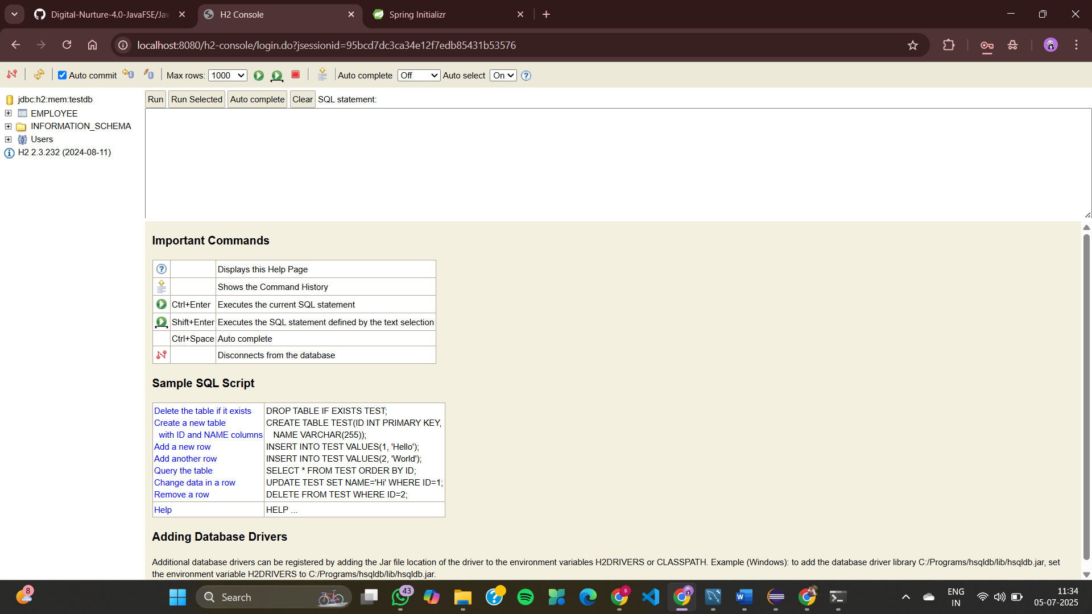

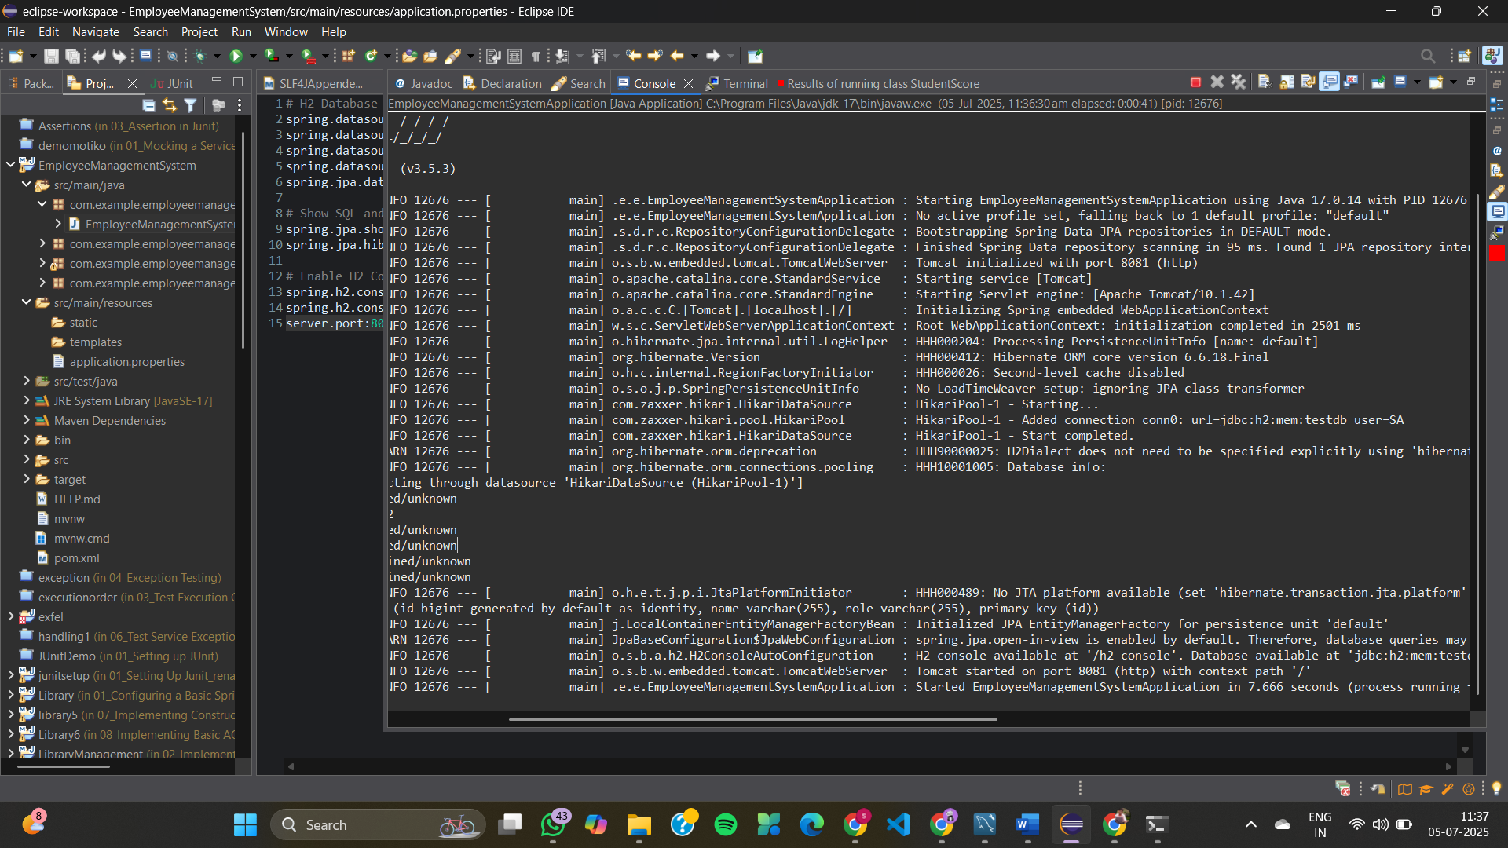

**Exercise 2: Employee Management System - Creating Entities**

**Department.java**

package com.example.demo.entity;

import jakarta.persistence.*;

import java.util.List;

@Entity

@Table(name = "departments")

public class Department {

@Id

@GeneratedValue(strategy = GenerationType.IDENTITY)

private Long id;

private String name;

@OneToMany(mappedBy = "department", cascade = CascadeType.ALL, orphanRemoval = true)

private List<Employee> employees;

public Department() {

}

public Long getId() {

return id;

}

public void setId(Long id) {

this.id = id;

}

public String getName() {

return name;

}

public void setName(String name) {

this.name = name;

}

public List<Employee> getEmployees() {

return employees;

}

public void setEmployees(List<Employee> employees) {

this.employees = employees;

}

}

**Employee.java**

package com.example.demo.entity;

import jakarta.persistence.*;

@Entity

@Table(name = "employees")

public class Employee {

@Id

@GeneratedValue(strategy = GenerationType.IDENTITY)

private Long id;

private String name;

private String email;

@ManyToOne

@JoinColumn(name = "department_id")

private Department department;

public Employee() {

}

// getters & setters

public Long getId() {

return id;

}

public void setId(Long id) {

this.id = id;

}

public String getName() {

return name;

}

public void setName(String name) {

this.name = name;

}

public String getEmail() {

return email;

}

public void setEmail(String email) {

this.email = email;

}

public Department getDepartment() {

return department;

}

public void setDepartment(Department department) {

this.department = department;

}

}

**DepartmentRepository.java**

package com.example.demo.repository;

import com.example.demo.entity.Department;

import org.springframework.data.jpa.repository.JpaRepository;

public interface DepartmentRepository extends JpaRepository<Department, Long> {

}

**EmployeeRepository.java**

package com.example.demo.repository;

import com.example.demo.entity.Employee;

import org.springframework.data.jpa.repository.JpaRepository;

public interface EmployeeRepository extends JpaRepository<Employee, Long> {

}

**EmployeeManagementSystemApplication.java**

package com.example.demo;

import com.example.demo.entity.Department;

import com.example.demo.entity.Employee;

import com.example.demo.repository.DepartmentRepository;

import org.springframework.boot.CommandLineRunner;

import org.springframework.boot.SpringApplication;

import org.springframework.boot.autoconfigure.SpringBootApplication;

import org.springframework.context.annotation.Bean;

import java.util.List;

@SpringBootApplication

public class EmployeeManagementSystemApplication {

public static void main(String[] args) {

SpringApplication.run(EmployeeManagementSystemApplication.class, args);

}

@Bean

public CommandLineRunner demo(DepartmentRepository deptRepo) {

return args -> {

Department dept = new Department();

dept.setName("IT");

Employee emp1 = new Employee();

emp1.setName("Alice");

emp1.setEmail("alice@example.com");

emp1.setDepartment(dept);

Employee emp2 = new Employee();

emp2.setName("Bob");

emp2.setEmail("bob@example.com");

emp2.setDepartment(dept);

dept.setEmployees(List.of(emp1, emp2));

deptRepo.save(dept);

};

}

}

**application.properties**

spring.datasource.url=jdbc:h2:mem:testdb

spring.datasource.driver-class-name=org.h2.Driver

spring.datasource.username=sa

spring.datasource.password=

spring.jpa.show-sql=true

spring.jpa.hibernate.ddl-auto=update

spring.h2.console.enabled=true

spring.h2.console.path=/h2-console

**pom.xml**

<project xmlns="http://maven.apache.org/POM/4.0.0"

xmlns:xsi="http://www.w3.org/2001/XMLSchema-instance"

xsi:schemaLocation="http://maven.apache.org/POM/4.0.0

https://maven.apache.org/xsd/maven-4.0.0.xsd">

<modelVersion>4.0.0</modelVersion>

<groupId>com.example</groupId>

<artifactId>employee-management-system</artifactId>

<version>0.0.1-SNAPSHOT</version>

<parent>

<groupId>org.springframework.boot</groupId>

<artifactId>spring-boot-starter-parent</artifactId>

<version>3.2.4</version>

</parent>

<dependencies>

<dependency>

<groupId>org.springframework.boot</groupId>

<artifactId>spring-boot-starter-data-jpa</artifactId>

</dependency>

<dependency>

<groupId>org.springframework.boot</groupId>

<artifactId>spring-boot-starter-web</artifactId>

</dependency>

<dependency>

<groupId>com.h2database</groupId>

<artifactId>h2</artifactId>

<scope>runtime</scope>

</dependency>

<dependency>

<groupId>org.projectlombok</groupId>

<artifactId>lombok</artifactId>

<optional>true</optional>

</dependency>

</dependencies>

<build>

<plugins>

<plugin>

<groupId>org.springframework.boot</groupId>

<artifactId>spring-boot-maven-plugin</artifactId>

</plugin>

</plugins>

</build>

</project>

**OUTPUT**

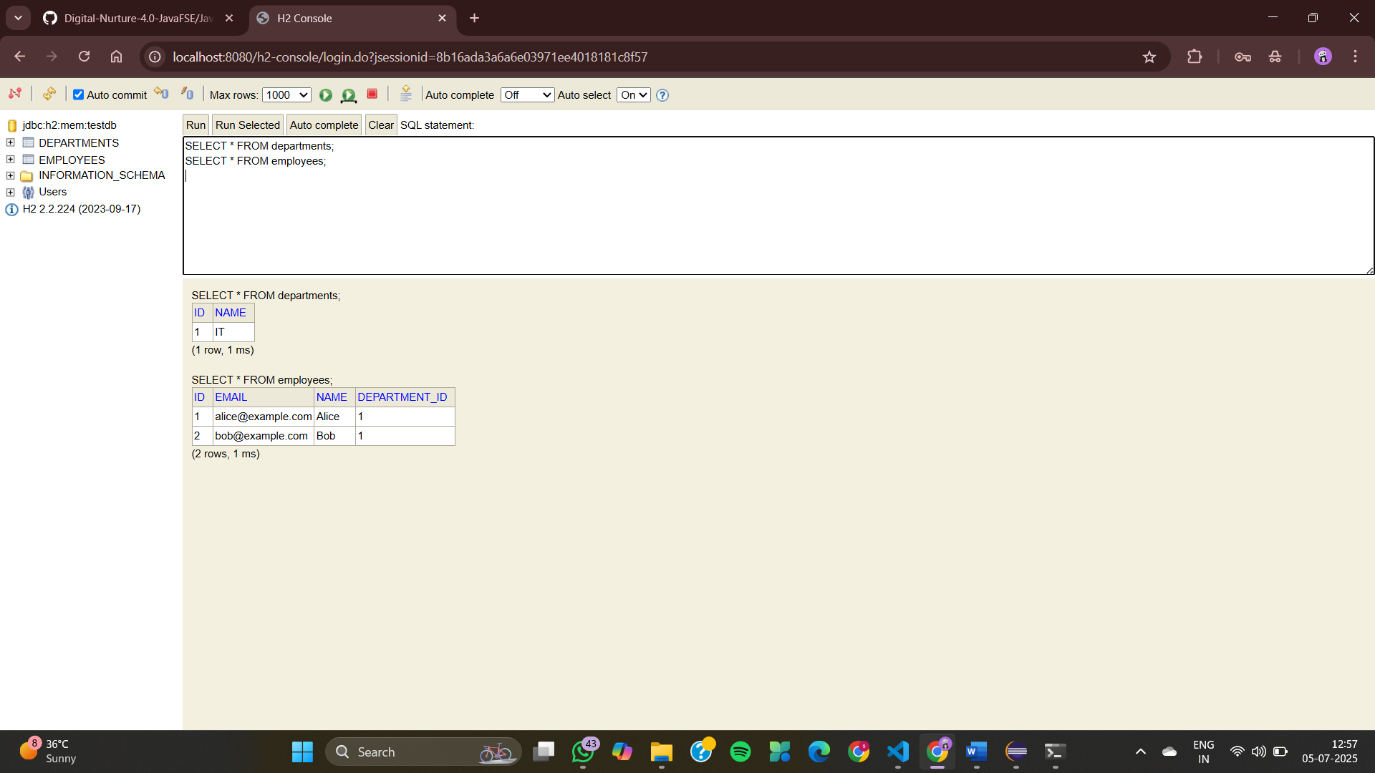

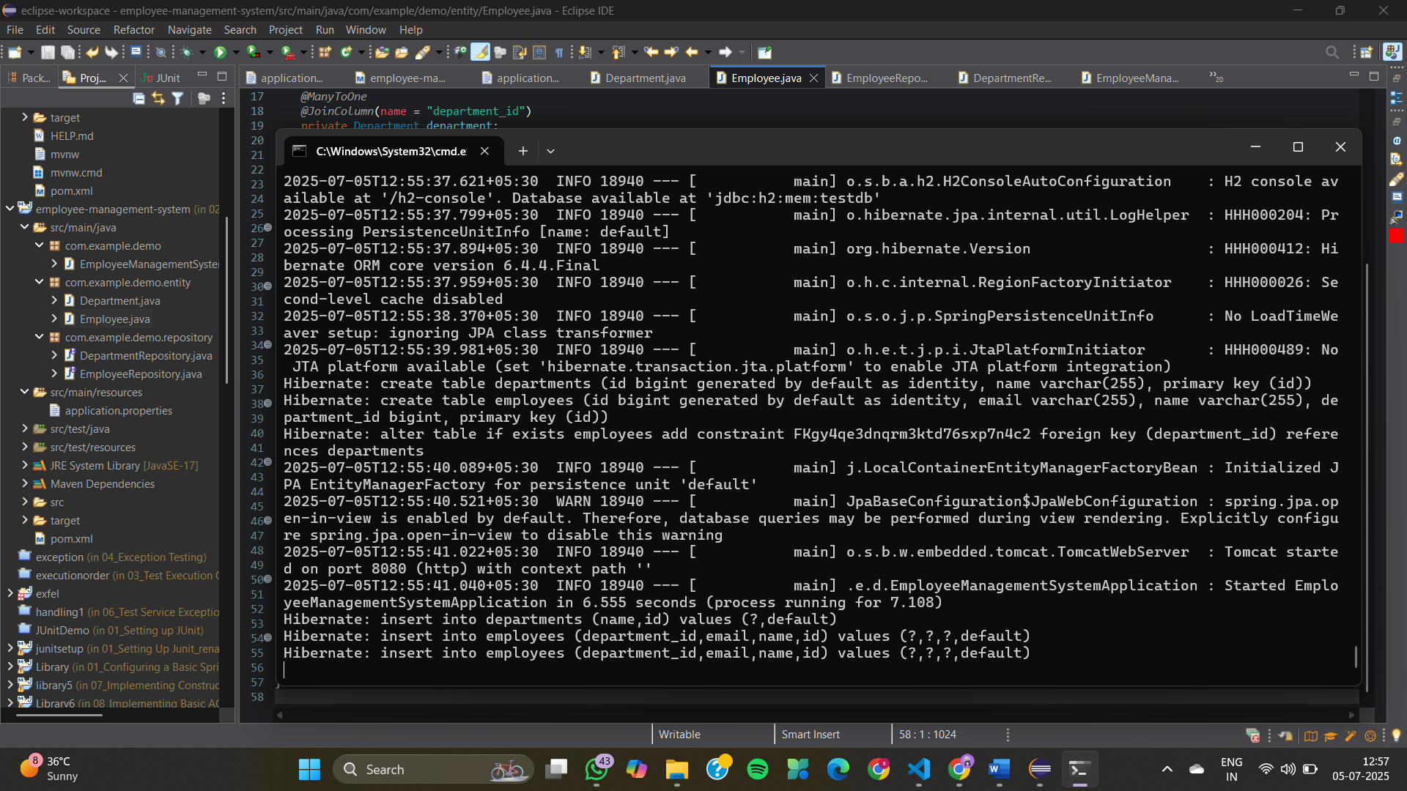

**Exercise 3: Employee Management System - Creating Repositories**

**Department.java**

package com.example.employee_management.entity;

import jakarta.persistence.*;

@Entity

public class Department {

@Id

@GeneratedValue(strategy = GenerationType.IDENTITY)

private Long id;

private String name;

public Department() {

}

public Department(String name) {

this.name = name;

}

// Getter & Setter for id

public Long getId() {

return id;

}

public void setId(Long id) {

this.id = id;

}

// Getter & Setter for name

public String getName() {

return name;

}

public void setName(String name) {

this.name = name;

}

@Override

public String toString() {

return "Department{" +

"id=" + id +

", name='" + name + '\'' +

'}';

}

}

**Employee.java**

package com.example.employee_management.entity;

import jakarta.persistence.*;

@Entity

public class Employee {

@Id

@GeneratedValue(strategy = GenerationType.IDENTITY)

private Long id;

private String name;

private String email;

@ManyToOne

@JoinColumn(name = "department_id")

private Department department;

public Employee() {

}

public Employee(String name, String email, Department department) {

this.name = name;

this.email = email;

this.department = department;

}

// Getter & Setter for id

public Long getId() {

return id;

}

public void setId(Long id) {

this.id = id;

}

// Getter & Setter for name

public String getName() {

return name;

}

public void setName(String name) {

this.name = name;

}

// Getter & Setter for email

public String getEmail() {

return email;

}

public void setEmail(String email) {

this.email = email;

}

// Getter & Setter for department

public Department getDepartment() {

return department;

}

public void setDepartment(Department department) {

this.department = department;

}

@Override

public String toString() {

return "Employee{" +

"id=" + id +

", name='" + name + '\'' +

", email='" + email + '\'' +

", department=" + department +

'}';

}

}

**DepartmentRepository.java**

package com.example.employee_management.repository;

import com.example.employee_management.entity.Department;

import org.springframework.data.jpa.repository.JpaRepository;

public interface DepartmentRepository extends JpaRepository<Department, Long> {

Department findByName(String name);

}

**EmployeeRepository.java**

package com.example.employee_management.repository;

import com.example.employee_management.entity.Employee;

import org.springframework.data.jpa.repository.JpaRepository;

import java.util.List;

public interface EmployeeRepository extends JpaRepository<Employee, Long> {

Employee findByEmail(String email);

List<Employee> findByDepartment_Name(String name);

}

**EmployeeManagementApplication.java**

package com.example.employee_management;

import com.example.employee_management.entity.Department;

import com.example.employee_management.entity.Employee;

import com.example.employee_management.repository.DepartmentRepository;

import com.example.employee_management.repository.EmployeeRepository;

import org.springframework.boot.CommandLineRunner;

import org.springframework.boot.SpringApplication;

import org.springframework.boot.autoconfigure.SpringBootApplication;

import org.springframework.context.annotation.Bean;

@SpringBootApplication

public class EmployeeManagementApplication {

public static void main(String[] args) {

SpringApplication.run(EmployeeManagementApplication.class, args);

}

@Bean

CommandLineRunner runner(EmployeeRepository employeeRepo, DepartmentRepository deptRepo) {

return args -> {

Department it = new Department();

it.setName("IT");

deptRepo.save(it);

Employee emp1 = new Employee();

emp1.setName("John Doe");

emp1.setEmail("john@example.com");

emp1.setDepartment(it);

employeeRepo.save(emp1);

Employee emp2 = new Employee();

emp2.setName("Jane Smith");

emp2.setEmail("jane@example.com");

emp2.setDepartment(it);

employeeRepo.save(emp2);

System.out.println("\nAll Employees:");

employeeRepo.findAll().forEach(System.out::println);

System.out.println("\nEmployee by Email:");

System.out.println(employeeRepo.findByEmail("jane@example.com"));

System.out.println("\nEmployees by Department Name:");

employeeRepo.findByDepartment_Name("IT").forEach(System.out::println);

};

}

}

**application.properties**

spring.application.name=employee-management

# H2 In-Memory DB config

spring.datasource.url=jdbc:h2:mem:testdb

spring.datasource.driver-class-name=org.h2.Driver

spring.datasource.username=sa

spring.datasource.password=

# JPA config

spring.jpa.hibernate.ddl-auto=update

spring.jpa.show-sql=true

# H2 console

spring.h2.console.enabled=true

**EmployeeManagementApplicationTests.java**

package com.example.employee_management;

import org.junit.jupiter.api.Test;

import org.springframework.boot.test.context.SpringBootTest;

@SpringBootTest

class EmployeeManagementApplicationTests {

@Test

void contextLoads() {

}

}

# pom.xml

<project xmlns="http://maven.apache.org/POM/4.0.0"

xmlns:xsi="http://www.w3.org/2001/XMLSchema-instance"

xsi:schemaLocation="http://maven.apache.org/POM/4.0.0

https://maven.apache.org/xsd/maven-4.0.0.xsd">

<modelVersion>4.0.0</modelVersion>

<groupId>com.example</groupId>

<artifactId>employee-management</artifactId>

<version>1.0.0</version>

<packaging>jar</packaging>

<name>Employee Management</name>

<parent>

<groupId>org.springframework.boot</groupId>

<artifactId>spring-boot-starter-parent</artifactId>

<version>3.3.0</version>

</parent>

<dependencies>

<!-- Spring Boot Starter Data JPA -->

<dependency>

<groupId>org.springframework.boot</groupId>

<artifactId>spring-boot-starter-data-jpa</artifactId>

</dependency>

<!-- H2 Database -->

<dependency>

<groupId>com.h2database</groupId>

<artifactId>h2</artifactId>

<scope>runtime</scope>

</dependency>

<!-- Lombok -->

<dependency>

<groupId>org.projectlombok</groupId>

<artifactId>lombok</artifactId>

<optional>true</optional>

</dependency>

<!-- Spring Boot Starter -->

<dependency>

<groupId>org.springframework.boot</groupId>

<artifactId>spring-boot-starter</artifactId>

</dependency>

<!-- Test (optional) -->

<dependency>

<groupId>org.springframework.boot</groupId>

<artifactId>spring-boot-starter-test</artifactId>

<scope>test</scope>

</dependency>

</dependencies>

<build>

<plugins>

<plugin>

<groupId>org.springframework.boot</groupId>

<artifactId>spring-boot-maven-plugin</artifactId>

</plugin>

</plugins>

</build>

</project>

**OUTPUT**

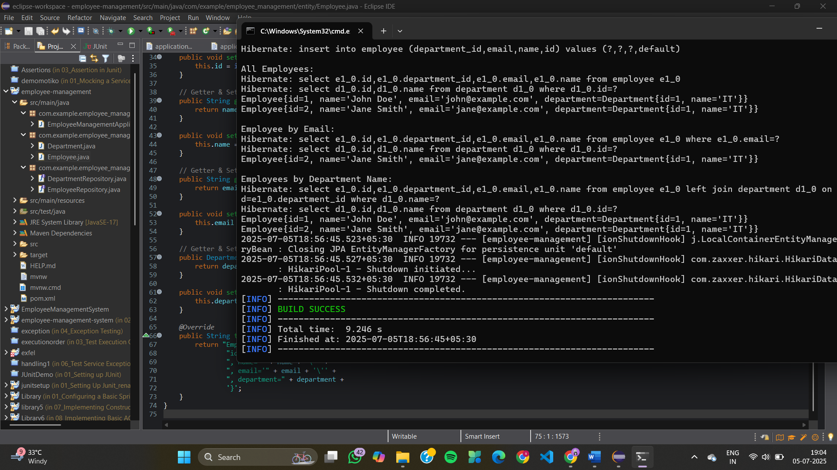

**Exercise 4: Employee Management System - Implementing CRUD Operations**

**DepartmentController.java**

package com.example.employee_management.controller;

import com.example.employee_management.entity.Department;

import com.example.employee_management.repository.DepartmentRepository;

import org.springframework.web.bind.annotation.*;

import java.util.List;

@RestController

@RequestMapping("/departments")

public class DepartmentController {

private final DepartmentRepository deptRepo;

public DepartmentController(DepartmentRepository deptRepo) {

this.deptRepo = deptRepo;

}

@GetMapping

public List<Department> getAll() {

return deptRepo.findAll();

}

@GetMapping("/{id}")

public Department getById(@PathVariable Long id) {

return deptRepo.findById(id).orElseThrow();

}

@PostMapping

public Department create(@RequestBody Department dept) {

return deptRepo.save(dept);

}

@PutMapping("/{id}")

public Department update(@PathVariable Long id, @RequestBody Department updatedDept) {

Department dept = deptRepo.findById(id).orElseThrow();

dept.setName(updatedDept.getName());

return deptRepo.save(dept);

}

@DeleteMapping("/{id}")

public void delete(@PathVariable Long id) {

deptRepo.deleteById(id);

}

}

**EmployeeController.java**

package com.example.employee_management.controller;

import com.example.employee_management.entity.Employee;

import com.example.employee_management.repository.EmployeeRepository;

import com.example.employee_management.repository.DepartmentRepository;

import org.springframework.web.bind.annotation.*;

import java.util.List;

@RestController

@RequestMapping("/employees")

public class EmployeeController {

private final EmployeeRepository empRepo;

private final DepartmentRepository deptRepo;

public EmployeeController(EmployeeRepository empRepo, DepartmentRepository deptRepo) {

this.empRepo = empRepo;

this.deptRepo = deptRepo;

}

@GetMapping

public List<Employee> getAll() {

return empRepo.findAll();

}

@GetMapping("/{id}")

public Employee getById(@PathVariable Long id) {

return empRepo.findById(id).orElseThrow();

}

@PostMapping

public Employee create(@RequestBody Employee emp) {

// Optional: make sure department exists

if (emp.getDepartment() != null) {

deptRepo.findById(emp.getDepartment().getId()).orElseThrow();

}

return empRepo.save(emp);

}

@PutMapping("/{id}")

public Employee update(@PathVariable Long id, @RequestBody Employee updatedEmp) {

Employee emp = empRepo.findById(id).orElseThrow();

emp.setName(updatedEmp.getName());

emp.setEmail(updatedEmp.getEmail());

if (updatedEmp.getDepartment() != null) {

deptRepo.findById(updatedEmp.getDepartment().getId()).orElseThrow();

emp.setDepartment(updatedEmp.getDepartment());

}

return empRepo.save(emp);

}

@DeleteMapping("/{id}")

public void delete(@PathVariable Long id) {

empRepo.deleteById(id);

}

}

**Department.java**

package com.example.employee_management.entity;

import jakarta.persistence.*;

@Entity

public class Department {

@Id

@GeneratedValue(strategy = GenerationType.IDENTITY)

private Long id;

private String name;

// 👉 Getter and Setter for id

public Long getId() {

return id;

}

public void setId(Long id) {

this.id = id;

}

// 👉 Getter and Setter for name

public String getName() {

return name;

}

public void setName(String name) {

this.name = name;

}

}

**Employee.java**

package com.example.employee_management.entity;

import jakarta.persistence.*;

@Entity

public class Employee {

@Id

@GeneratedValue(strategy = GenerationType.IDENTITY)

private Long id;

private String name;

private String email;

@ManyToOne

@JoinColumn(name = "department_id")

private Department department;

// 👉 Getter and Setter for id

public Long getId() {

return id;

}

public void setId(Long id) {

this.id = id;

}

// 👉 Getter and Setter for name

public String getName() {

return name;

}

public void setName(String name) {

this.name = name;

}

// 👉 Getter and Setter for email

public String getEmail() {

return email;

}

public void setEmail(String email) {

this.email = email;

}

// 👉 Getter and Setter for department

public Department getDepartment() {

return department;

}

public void setDepartment(Department department) {

this.department = department;

}

}

**DepartmentRepository.java**

package com.example.employee_management.repository;

import com.example.employee_management.entity.Department;

import org.springframework.data.jpa.repository.JpaRepository;

public interface DepartmentRepository extends JpaRepository<Department, Long> {

}

**EmployeeRepository.java**

package com.example.employee_management.repository;

import com.example.employee_management.entity.Employee;

import org.springframework.data.jpa.repository.JpaRepository;

public interface EmployeeRepository extends JpaRepository<Employee, Long> {

}

**EmployeeManagementApplication.java**

package com.example.employee_management;

import org.springframework.boot.SpringApplication;

import org.springframework.boot.autoconfigure.SpringBootApplication;

@SpringBootApplication

public class EmployeeManagementApplication {

public static void main(String[] args) {

SpringApplication.run(EmployeeManagementApplication.class, args);

}

}

**application.properties**

spring.application.name=employee-management

# H2 In-Memory DB config

spring.datasource.url=jdbc:h2:mem:testdb

spring.datasource.driver-class-name=org.h2.Driver

spring.datasource.username=sa

spring.datasource.password=

# JPA config

spring.jpa.hibernate.ddl-auto=update

spring.jpa.show-sql=true

# H2 console

spring.h2.console.enabled=true

**EmployeeManagementApplicationTests.java**

package com.example.employee_management;

import org.junit.jupiter.api.Test;

import org.springframework.boot.test.context.SpringBootTest;

@SpringBootTest

class EmployeeManagementApplicationTests {

@Test

void contextLoads() {

}

}

**pom.xml**

<project xmlns="http://maven.apache.org/POM/4.0.0"

xmlns:xsi="http://www.w3.org/2001/XMLSchema-instance"

xsi:schemaLocation="http://maven.apache.org/POM/4.0.0

https://maven.apache.org/xsd/maven-4.0.0.xsd">

<modelVersion>4.0.0</modelVersion>

<groupId>com.example</groupId>

<artifactId>employee-management</artifactId>

<version>1.0.0</version>

<packaging>jar</packaging>

<name>Employee Management</name>

<parent>

<groupId>org.springframework.boot</groupId>

<artifactId>spring-boot-starter-parent</artifactId>

<version>3.3.0</version>

</parent>

<dependencies>

<!-- Spring Boot Starter Web (IMPORTANT!) -->

<dependency>

<groupId>org.springframework.boot</groupId>

<artifactId>spring-boot-starter-web</artifactId>

</dependency>

<!-- Spring Boot Starter Data JPA -->

<dependency>

<groupId>org.springframework.boot</groupId>

<artifactId>spring-boot-starter-data-jpa</artifactId>

</dependency>

<!-- H2 Database -->

<dependency>

<groupId>com.h2database</groupId>

<artifactId>h2</artifactId>

<scope>runtime</scope>

</dependency>

<!-- Lombok -->

<dependency>

<groupId>org.projectlombok</groupId>

<artifactId>lombok</artifactId>

<optional>true</optional>

</dependency>

<!-- Spring Boot Starter (optional, already included by web) -->

<dependency>

<groupId>org.springframework.boot</groupId>

<artifactId>spring-boot-starter</artifactId>

</dependency>

<!-- Test -->

<dependency>

<groupId>org.springframework.boot</groupId>

<artifactId>spring-boot-starter-test</artifactId>

<scope>test</scope>

</dependency>

</dependencies>

<build>

<plugins>

<plugin>

<groupId>org.springframework.boot</groupId>

<artifactId>spring-boot-maven-plugin</artifactId>

</plugin>

</plugins>

</build>

</project>

**OUTPUT**

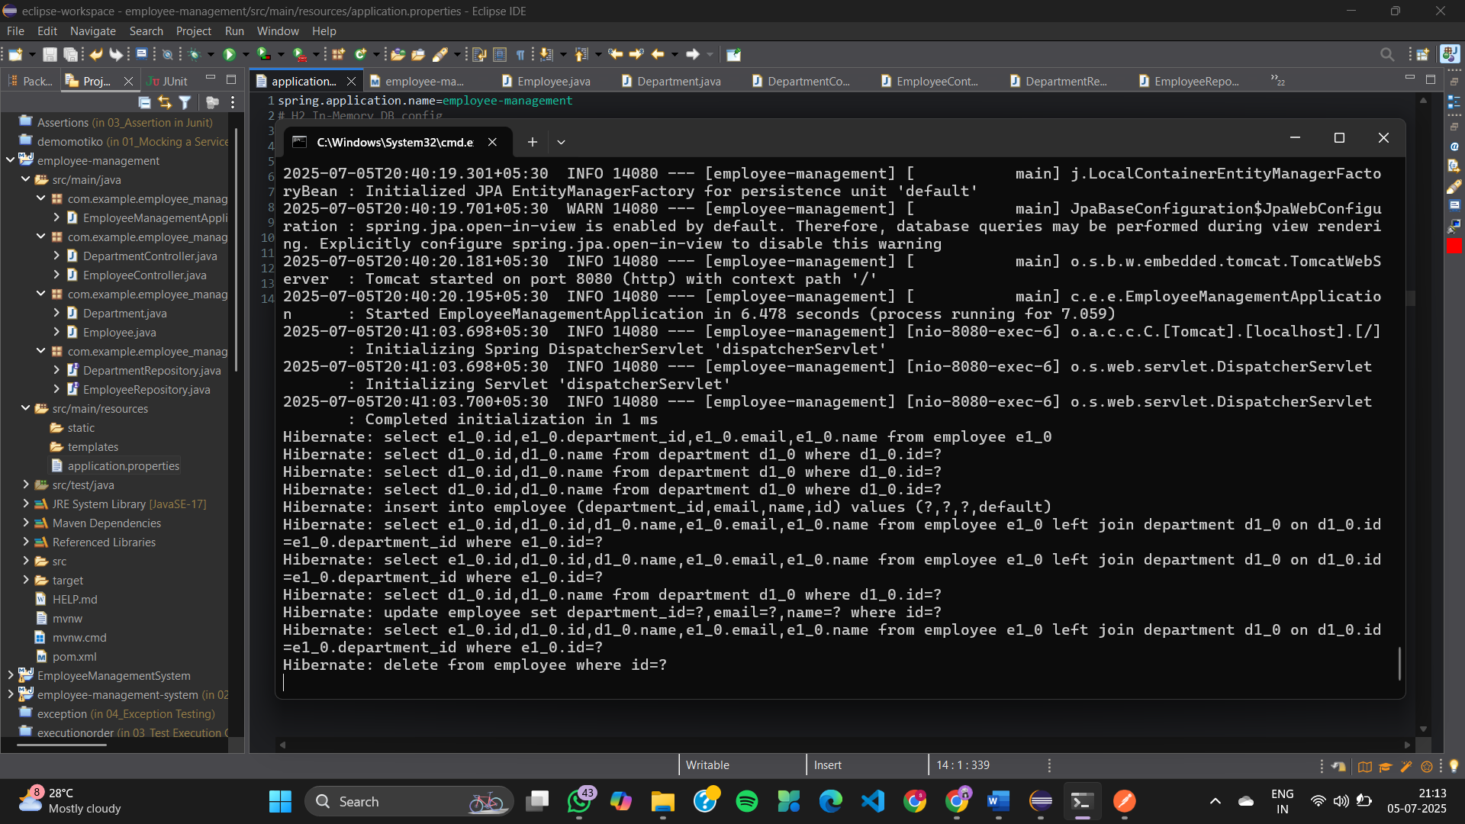

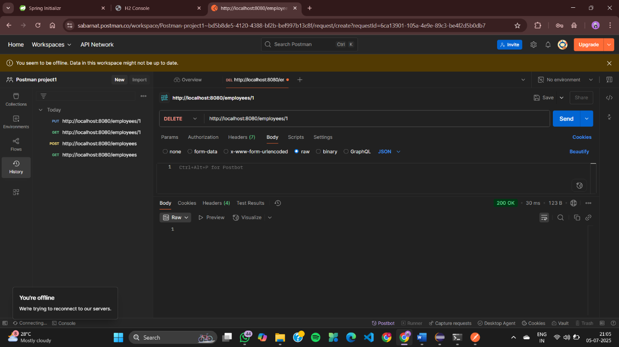

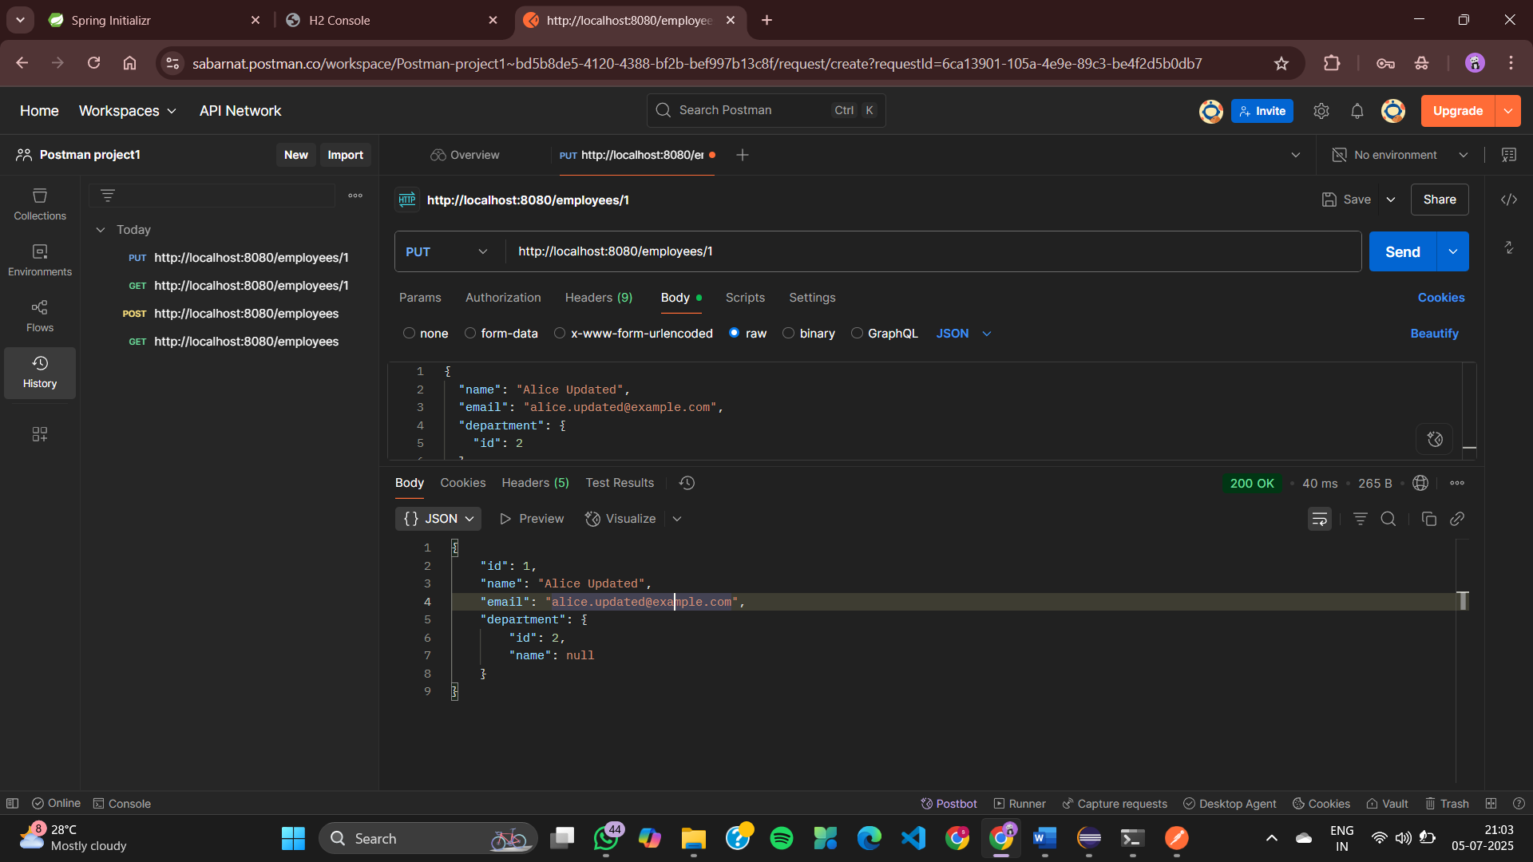

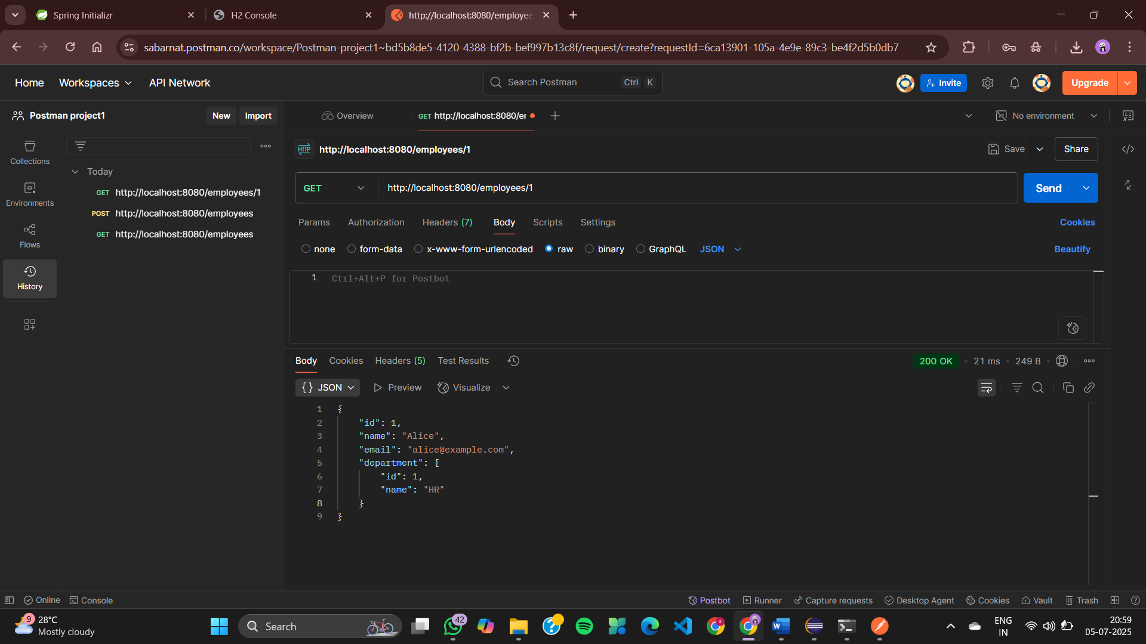

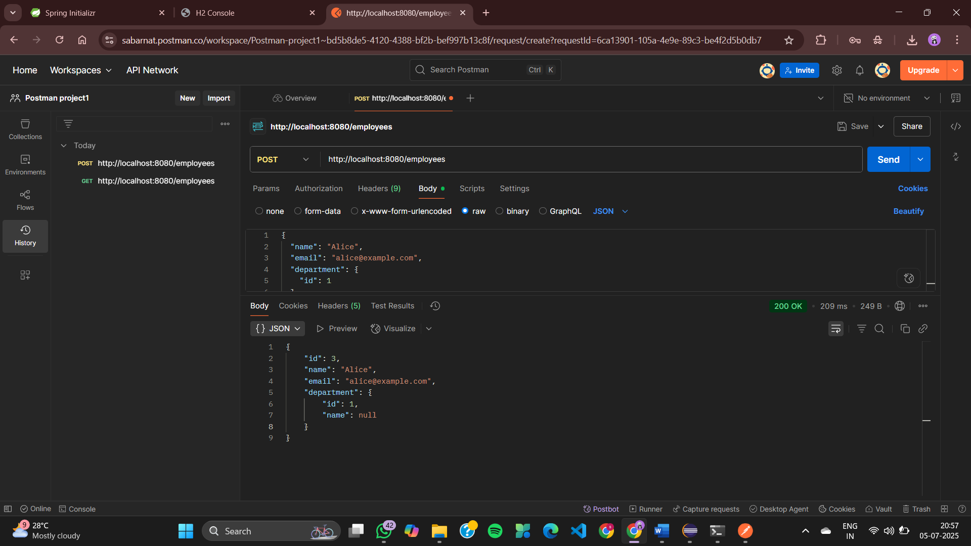

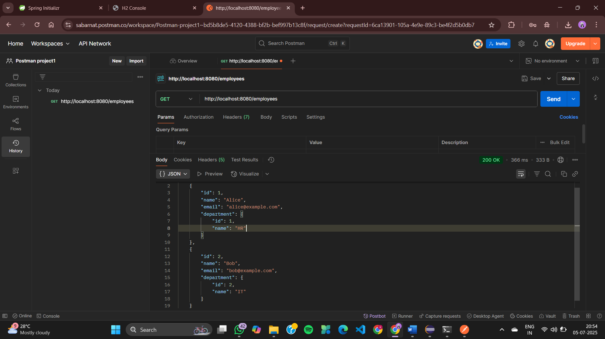

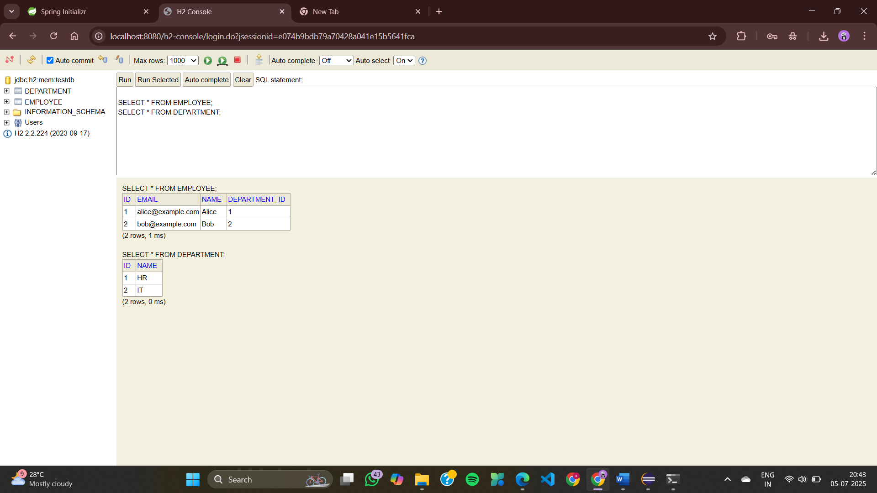

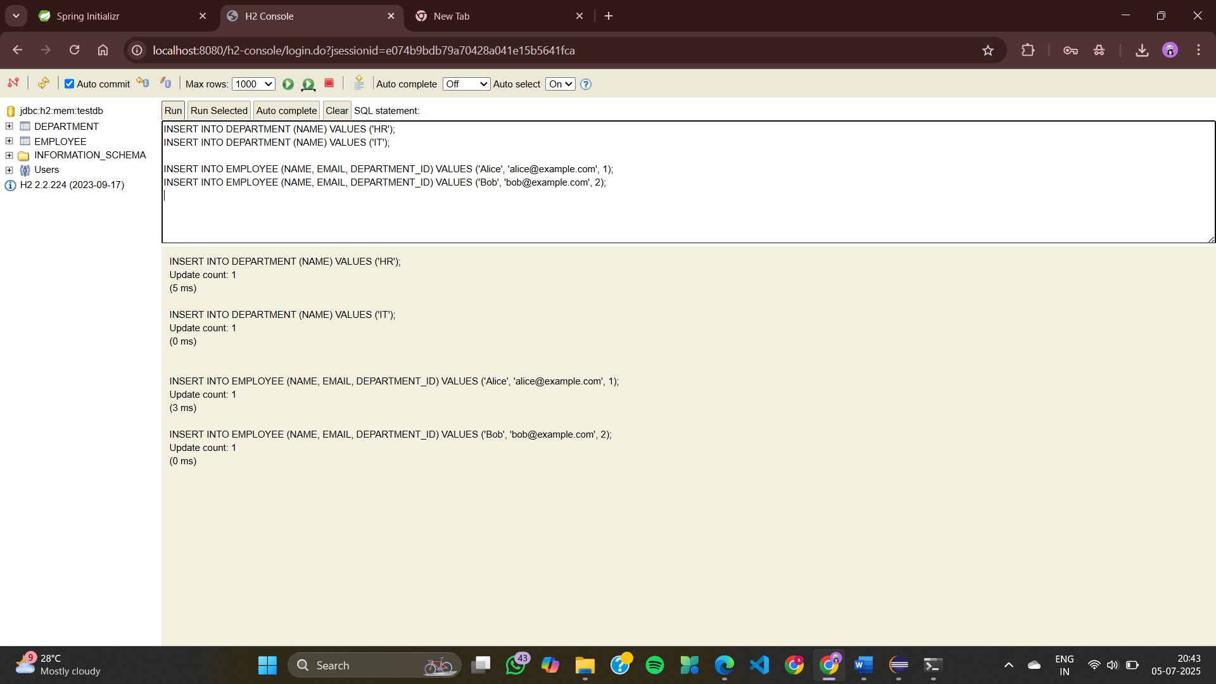

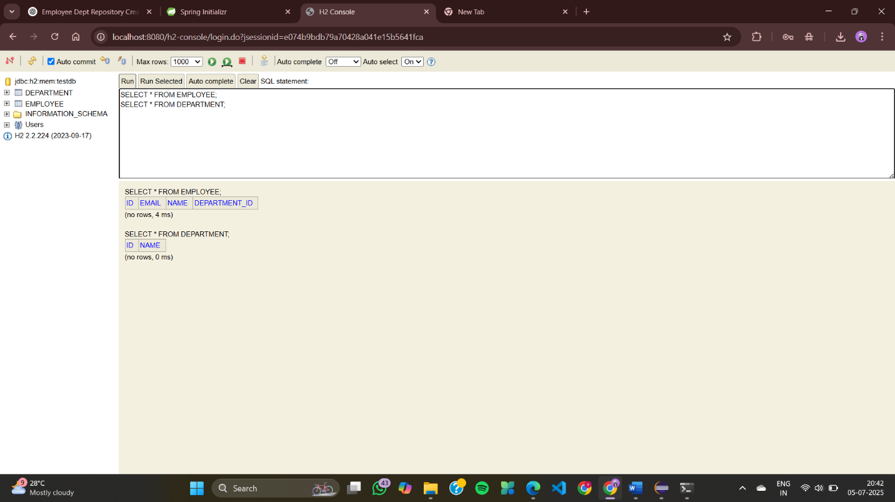

**Exercise 5: Employee Management System - Defining Query Methods**

**DepartmentController.java**

package com.example.employee_management.controller;

import com.example.employee_management.entity.Department;

import com.example.employee_management.repository.DepartmentRepository;

import org.springframework.web.bind.annotation.*;

import java.util.List;

@RestController

@RequestMapping("/departments")

public class DepartmentController {

private final DepartmentRepository deptRepo;

public DepartmentController(DepartmentRepository deptRepo) {

this.deptRepo = deptRepo;

}

@GetMapping

public List<Department> getAll() {

return deptRepo.findAll();

}

@GetMapping("/{id}")

public Department getById(@PathVariable Long id) {

return deptRepo.findById(id).orElseThrow();

}

@PostMapping

public Department create(@RequestBody Department dept) {

return deptRepo.save(dept);

}

@PutMapping("/{id}")

public Department update(@PathVariable Long id, @RequestBody Department updatedDept) {

Department dept = deptRepo.findById(id).orElseThrow();

dept.setName(updatedDept.getName());

return deptRepo.save(dept);

}

@DeleteMapping("/{id}")

public void delete(@PathVariable Long id) {

deptRepo.deleteById(id);

}

}

**EmployeeController.java**

package com.example.employee_management.controller;

import com.example.employee_management.entity.Employee;

import com.example.employee_management.repository.EmployeeRepository;

import com.example.employee_management.repository.DepartmentRepository;

import org.springframework.web.bind.annotation.*;

import java.util.List;

@RestController

@RequestMapping("/employees")

public class EmployeeController {

private final EmployeeRepository empRepo;

private final DepartmentRepository deptRepo;

public EmployeeController(EmployeeRepository empRepo, DepartmentRepository deptRepo) {

this.empRepo = empRepo;

this.deptRepo = deptRepo;

}

@GetMapping("/department/{name}")

public List<Employee> getByDepartmentName(@PathVariable String name) {

return empRepo.findByDepartment_Name(name);

}

@GetMapping("/name/{namePart}")

public List<Employee> getByNameContaining(@PathVariable String namePart) {

return empRepo.findByNameContainingIgnoreCase(namePart);

}

@GetMapping("/email/{email}")

public Employee getByEmail(@PathVariable String email) {

return empRepo.findByEmail(email);

}

@GetMapping("/namedquery/department/{id}")

public List<Employee> getByDepartmentIdNamedQuery(@PathVariable Long id) {

return empRepo.findByDepartmentId(id);

}

// existing CRUD endpoints…

}

**Department.java**

package com.example.employee_management.entity;

import jakarta.persistence.*;

@Entity

public class Department {

@Id

@GeneratedValue(strategy = GenerationType.IDENTITY)

private Long id;

private String name;

// 👉 Getter and Setter for id

public Long getId() {

return id;

}

public void setId(Long id) {

this.id = id;

}

// 👉 Getter and Setter for name

public String getName() {

return name;

}

public void setName(String name) {

this.name = name;

}

}

**Employee.java**

package com.example.employee_management.entity;

import jakarta.persistence.*;

@NamedQueries({

@NamedQuery(

name = "Employee.findByDepartmentId",

query = "SELECT e FROM Employee e WHERE e.department.id = :deptId"

),

@NamedQuery(

name = "Employee.findAllOrderedByName",

query = "SELECT e FROM Employee e ORDER BY e.name ASC"

)

})

@Entity

public class Employee {

@Id

@GeneratedValue(strategy = GenerationType.IDENTITY)

private Long id;

private String name;

private String email;

@ManyToOne

@JoinColumn(name = "department_id")

private Department department;

// getters and setters…

public Long getId() {

return id;

}

public void setId(Long id) {

this.id = id;

}

public String getName() {

return name;

}

public void setName(String name) {

this.name = name;

}

public String getEmail() {

return email;

}

public void setEmail(String email) {

this.email = email;

}

public Department getDepartment() {

return department;

}

public void setDepartment(Department department) {

this.department = department;

}

}

**DepartmentRepository.java**

package com.example.employee_management.repository;

import com.example.employee_management.entity.Department;

import org.springframework.data.jpa.repository.JpaRepository;

public interface DepartmentRepository extends JpaRepository<Department, Long> {

}

**EmployeeRepository.java**

package com.example.employee_management.repository;

import com.example.employee_management.entity.Employee;

import org.springframework.data.jpa.repository.JpaRepository;

import org.springframework.data.jpa.repository.Query;

import org.springframework.data.repository.query.Param;

import java.util.List;

public interface EmployeeRepository extends JpaRepository<Employee, Long> {

// Derived Query: find employees by department name

List<Employee> findByDepartment_Name(String deptName);

// Derived Query: find employees with name containing string (case-insensitive)

List<Employee> findByNameContainingIgnoreCase(String name);

// @Query: find employee by email

@Query("SELECT e FROM Employee e WHERE e.email = :email")

Employee findByEmail(@Param("email") String email);

// @Query: find employees in department by deptName

@Query("SELECT e FROM Employee e WHERE e.department.name = ?1")

List<Employee> getEmployeesInDepartment(String deptName);

// Named Query: find by departmentId

@Query(name = "Employee.findByDepartmentId")

List<Employee> findByDepartmentId(@Param("deptId") Long deptId);

}

**EmployeeManagementApplication.java**

package com.example.employee_management;

import org.springframework.boot.SpringApplication;

import org.springframework.boot.autoconfigure.SpringBootApplication;

@SpringBootApplication

public class EmployeeManagementApplication {

public static void main(String[] args) {

SpringApplication.run(EmployeeManagementApplication.class, args);

}

}

**application.properties**

spring.application.name=employee-management

# H2 In-Memory DB config

spring.datasource.url=jdbc:h2:mem:testdb

spring.datasource.driver-class-name=org.h2.Driver

spring.datasource.username=sa

spring.datasource.password=

# JPA config

spring.jpa.hibernate.ddl-auto=update

spring.jpa.show-sql=true

# H2 console

spring.h2.console.enabled=true

**EmployeeManagementApplicationTests.java**

package com.example.employee_management;

import org.junit.jupiter.api.Test;

import org.springframework.boot.test.context.SpringBootTest;

@SpringBootTest

class EmployeeManagementApplicationTests {

@Test

void contextLoads() {

}

}

**OUTPUT**

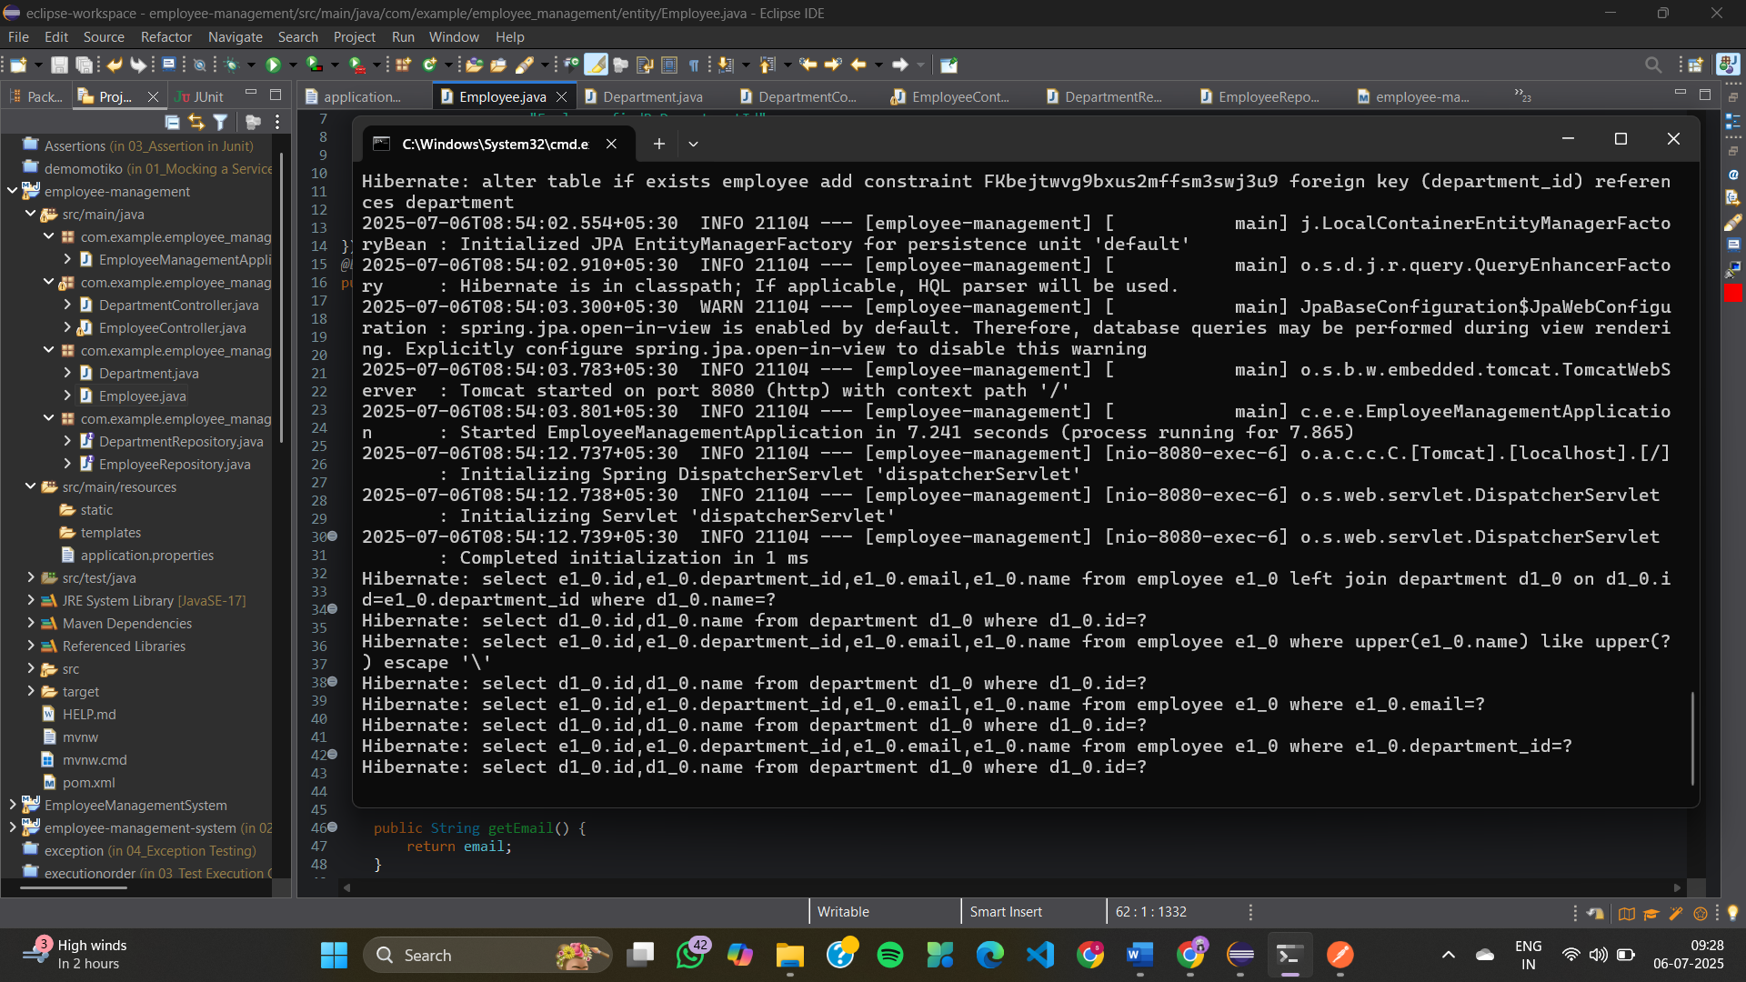

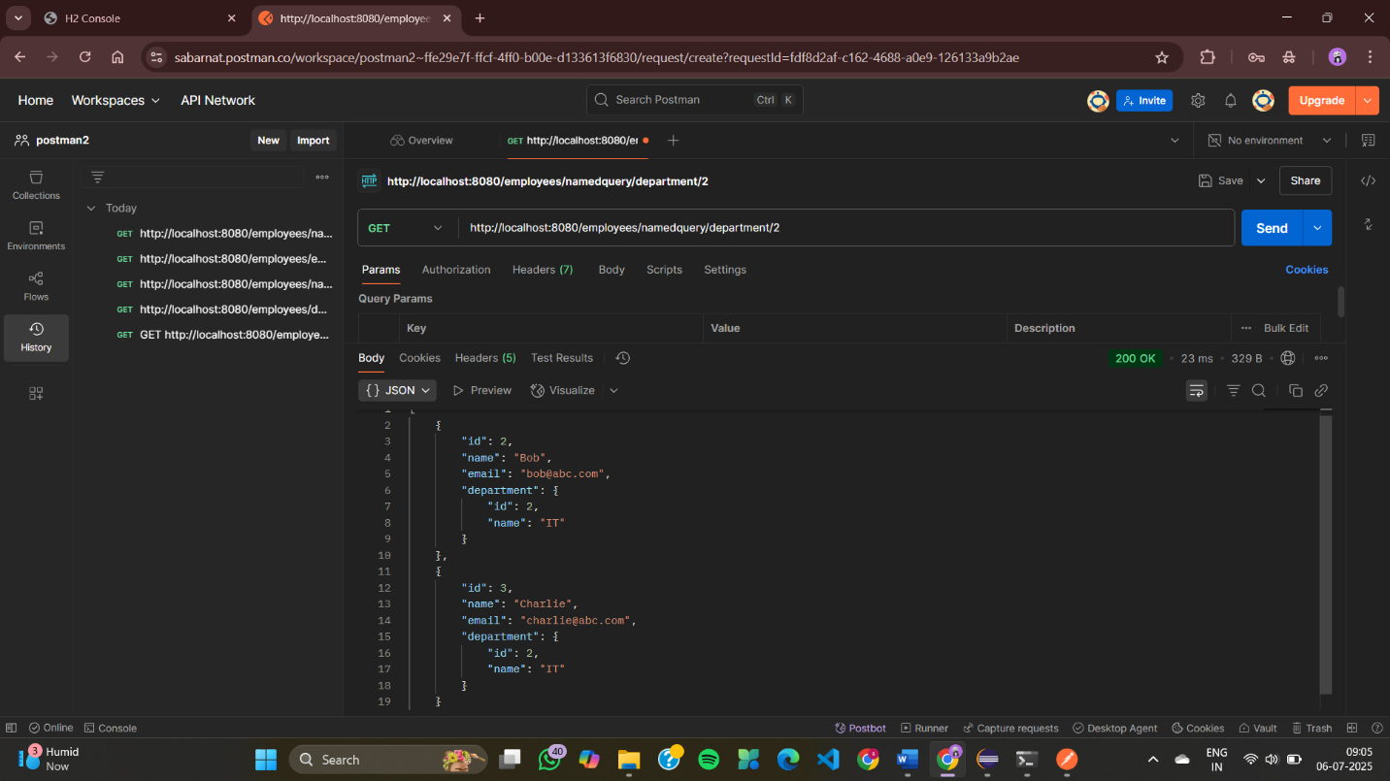

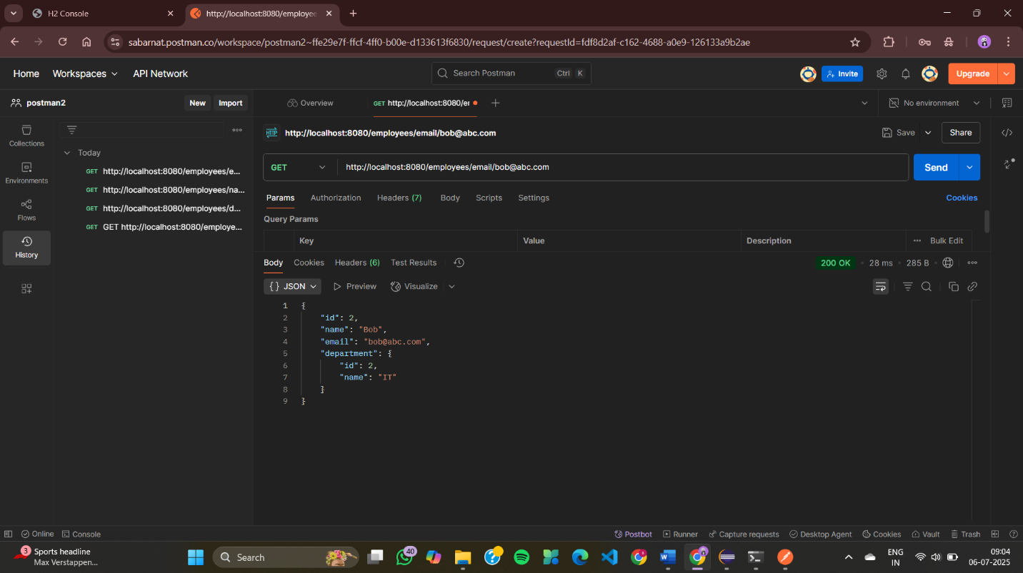

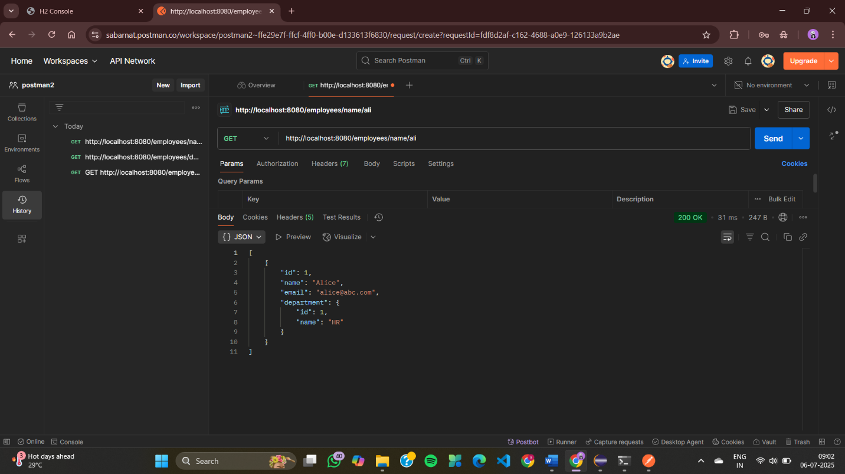

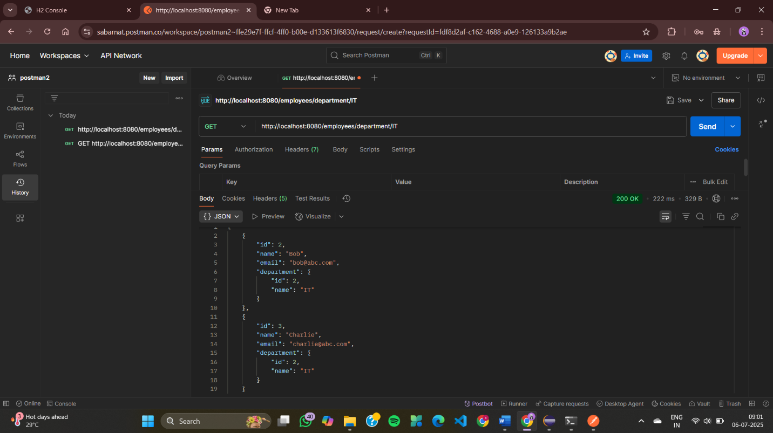

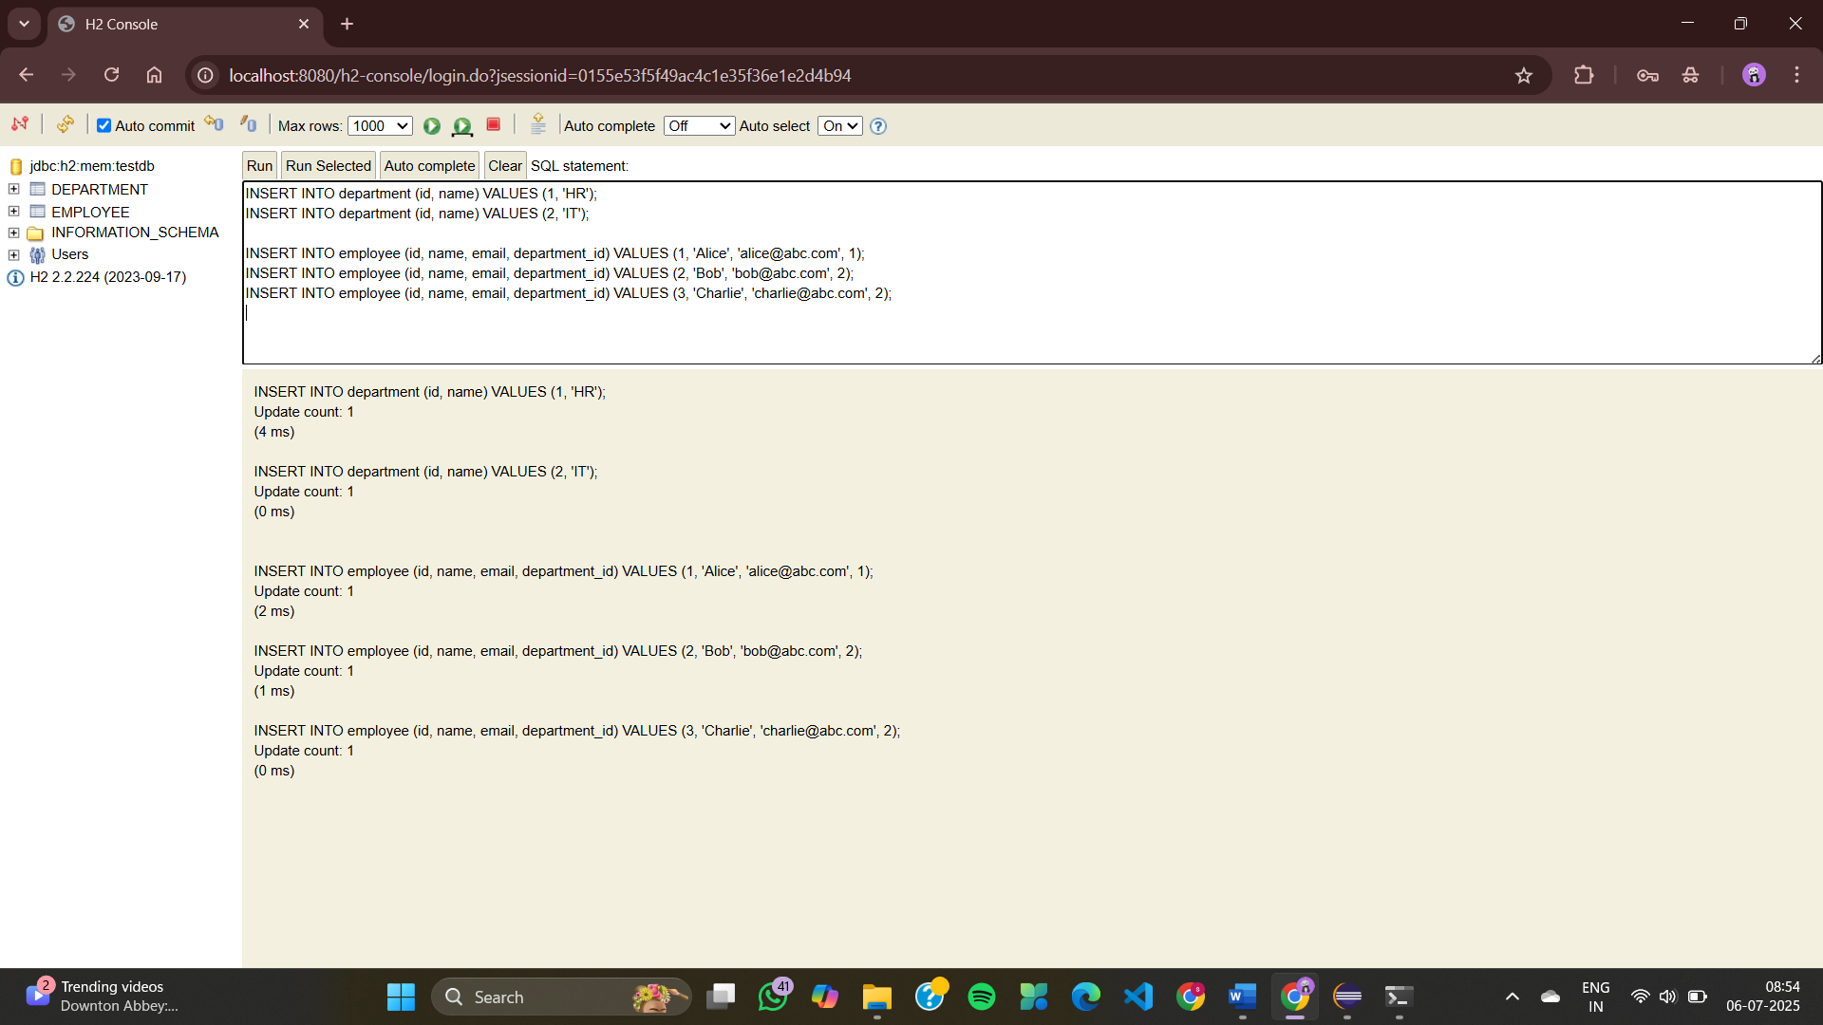

**Exercise 6: Employee Management System - Implementing Pagination and Sorting**

**DepartmentController.java**

package com.example.employee_management.controller;

import com.example.employee_management.entity.Department;

import com.example.employee_management.repository.DepartmentRepository;

import org.springframework.web.bind.annotation.*;

import java.util.List;

@RestController

@RequestMapping("/departments")

public class DepartmentController {

private final DepartmentRepository deptRepo;

public DepartmentController(DepartmentRepository deptRepo) {

this.deptRepo = deptRepo;

}

@GetMapping

public List<Department> getAll() {

return deptRepo.findAll();

}

@GetMapping("/{id}")

public Department getById(@PathVariable Long id) {

return deptRepo.findById(id).orElseThrow();

}

@PostMapping

public Department create(@RequestBody Department dept) {

return deptRepo.save(dept);

}

@PutMapping("/{id}")

public Department update(@PathVariable Long id, @RequestBody Department updatedDept) {

Department dept = deptRepo.findById(id).orElseThrow();

dept.setName(updatedDept.getName());

return deptRepo.save(dept);

}

@DeleteMapping("/{id}")

public void delete(@PathVariable Long id) {

deptRepo.deleteById(id);

}

}

**EmployeeController.java**

package com.example.employee_management.controller;

import com.example.employee_management.entity.Employee;

import com.example.employee_management.repository.EmployeeRepository;

import com.example.employee_management.repository.DepartmentRepository;

import org.springframework.data.domain.*;

import org.springframework.web.bind.annotation.*;

import java.util.List;

@RestController

@RequestMapping("/employees")

public class EmployeeController {

private final EmployeeRepository empRepo;

private final DepartmentRepository deptRepo;

public EmployeeController(EmployeeRepository empRepo, DepartmentRepository deptRepo) {

this.empRepo = empRepo;

this.deptRepo = deptRepo;

}

@GetMapping

public List<Employee> getAll() {

return empRepo.findAll();

}

@GetMapping("/{id}")

public Employee getById(@PathVariable Long id) {

return empRepo.findById(id).orElseThrow();

}

@PostMapping

public Employee create(@RequestBody Employee emp) {

if (emp.getDepartment() != null) {

deptRepo.findById(emp.getDepartment().getId()).orElseThrow();

}

return empRepo.save(emp);

}

@PutMapping("/{id}")

public Employee update(@PathVariable Long id, @RequestBody Employee updatedEmp) {

Employee emp = empRepo.findById(id).orElseThrow();

emp.setName(updatedEmp.getName());

emp.setEmail(updatedEmp.getEmail());

if (updatedEmp.getDepartment() != null) {

deptRepo.findById(updatedEmp.getDepartment().getId()).orElseThrow();

emp.setDepartment(updatedEmp.getDepartment());

}

return empRepo.save(emp);

}

@DeleteMapping("/{id}")

public void delete(@PathVariable Long id) {

empRepo.deleteById(id);

}

@GetMapping("/paginated")

public Page<Employee> getPaginated(

@RequestParam(defaultValue = "0") int page,

@RequestParam(defaultValue = "5") int size,

@RequestParam(defaultValue = "id") String sortBy,

@RequestParam(defaultValue = "asc") String direction) {

Pageable pageable = PageRequest.of(

page,

size,

direction.equalsIgnoreCase("asc") ?

Sort.by(sortBy).ascending() :

Sort.by(sortBy).descending()

);

return empRepo.findAll(pageable);

}

}

**Department.java**

package com.example.employee_management.entity;

import jakarta.persistence.*;

@Entity

public class Department {

@Id

@GeneratedValue(strategy = GenerationType.IDENTITY)

private Long id;

private String name;

public Long getId() { return id; }

public void setId(Long id) { this.id = id; }

public String getName() { return name; }

public void setName(String name) { this.name = name; }

}

**Employee.java**

package com.example.employee_management.entity;

import jakarta.persistence.*;

@Entity

public class Employee {

@Id

@GeneratedValue(strategy = GenerationType.IDENTITY)

private Long id;

private String name;

private String email;

@ManyToOne

@JoinColumn(name = "department_id")

private Department department;

public Long getId() { return id; }

public void setId(Long id) { this.id = id; }

public String getName() { return name; }

public void setName(String name) { this.name = name; }

public String getEmail() { return email; }

public void setEmail(String email) { this.email = email; }

public Department getDepartment() { return department; }

public void setDepartment(Department department) { this.department = department; }

}

**DepartmentRepository.java**

package com.example.employee_management.repository;

import com.example.employee_management.entity.Department;

import org.springframework.data.jpa.repository.JpaRepository;

public interface DepartmentRepository extends JpaRepository<Department, Long> {

}

**EmployeeRepository.java**

package com.example.employee_management.repository;

import com.example.employee_management.entity.Employee;

import org.springframework.data.jpa.repository.JpaRepository;

public interface EmployeeRepository extends JpaRepository<Employee, Long> {

}

**EmployeeManagementApplication.java**

package com.example.employee_management;

import org.springframework.boot.SpringApplication;

import org.springframework.boot.autoconfigure.SpringBootApplication;

@SpringBootApplication

public class EmployeeManagementApplication {

public static void main(String[] args) {

SpringApplication.run(EmployeeManagementApplication.class, args);

}

}

**application.properties**

spring.application.name=employee-management

spring.datasource.url=jdbc:h2:mem:testdb

spring.datasource.driver-class-name=org.h2.Driver

spring.datasource.username=sa

spring.datasource.password=

spring.jpa.hibernate.ddl-auto=update

spring.jpa.show-sql=true

spring.h2.console.enabled=true

**EmployeeManagementApplicationTests.java**

package com.example.employee_management;

import org.junit.jupiter.api.Test;

import org.springframework.boot.test.context.SpringBootTest;

@SpringBootTest

class EmployeeManagementApplicationTests {

@Test

void contextLoads() {

}

}

**OUTPUT**

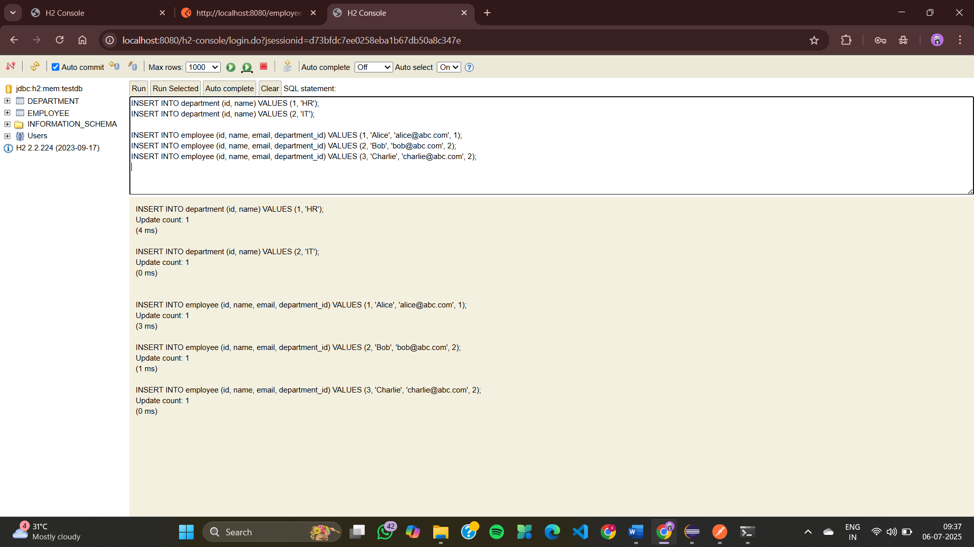

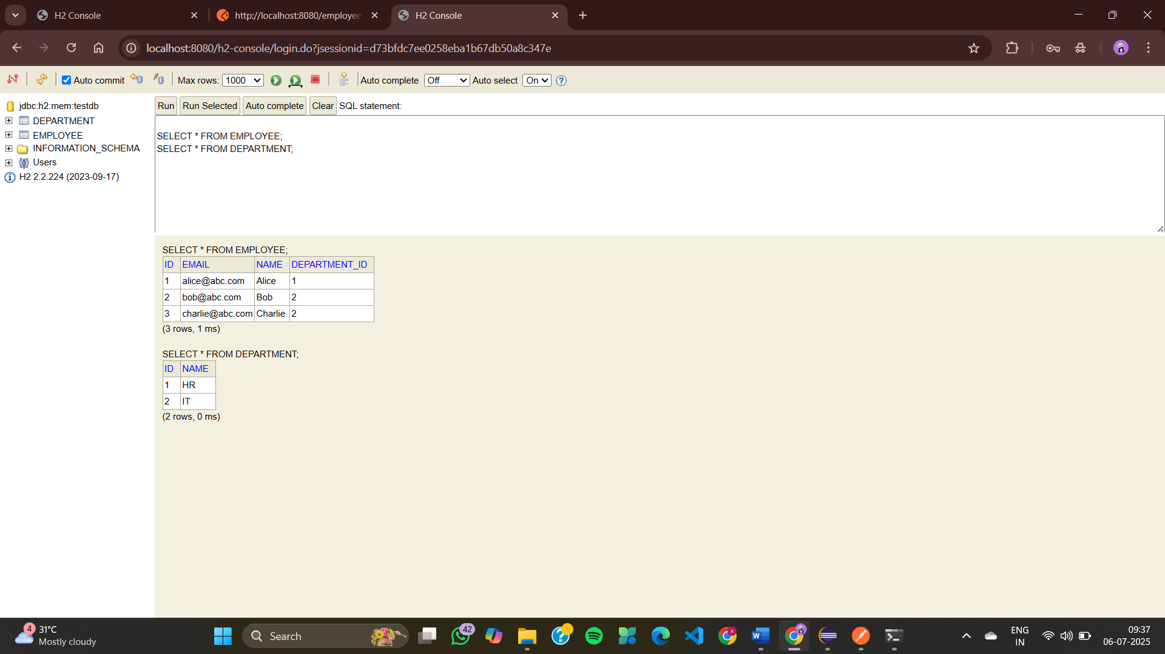

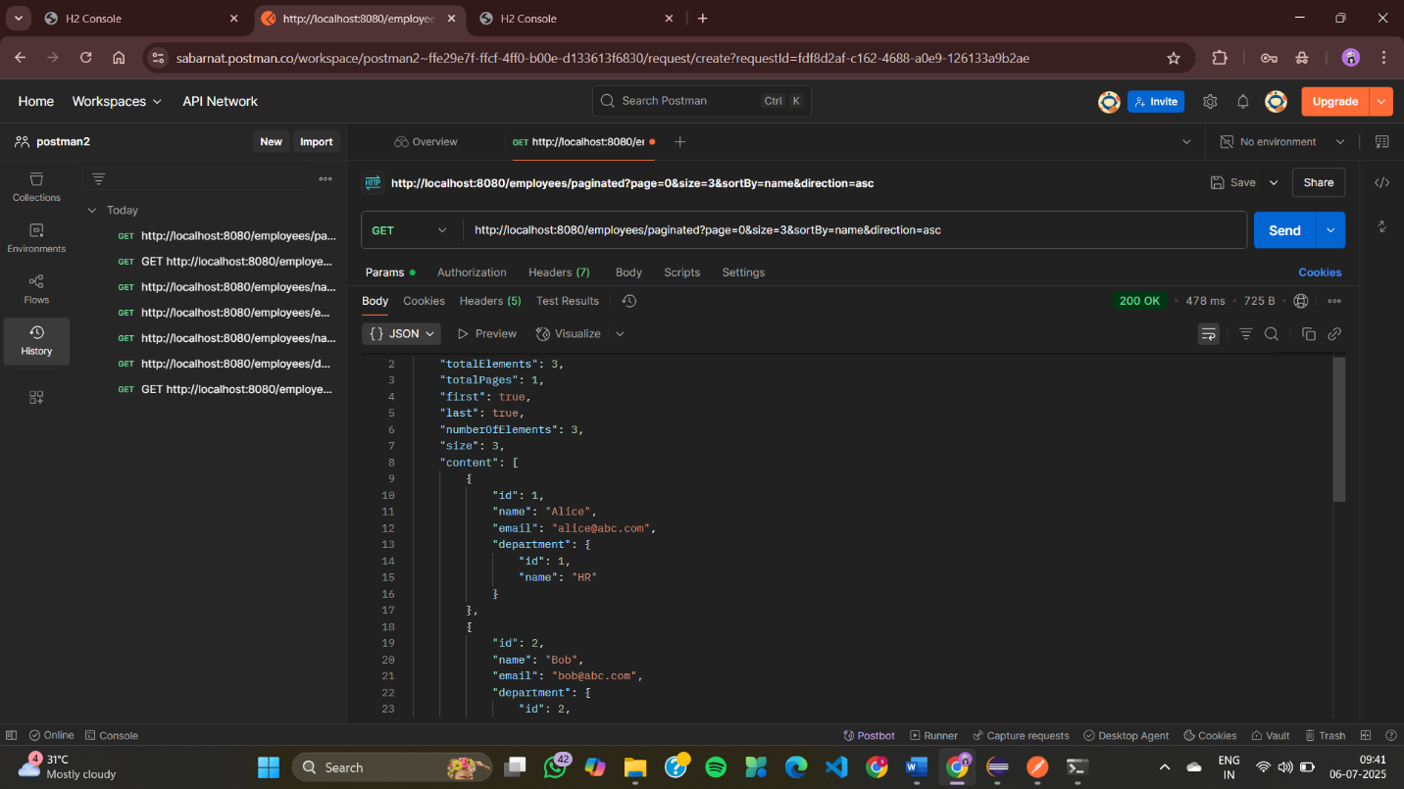

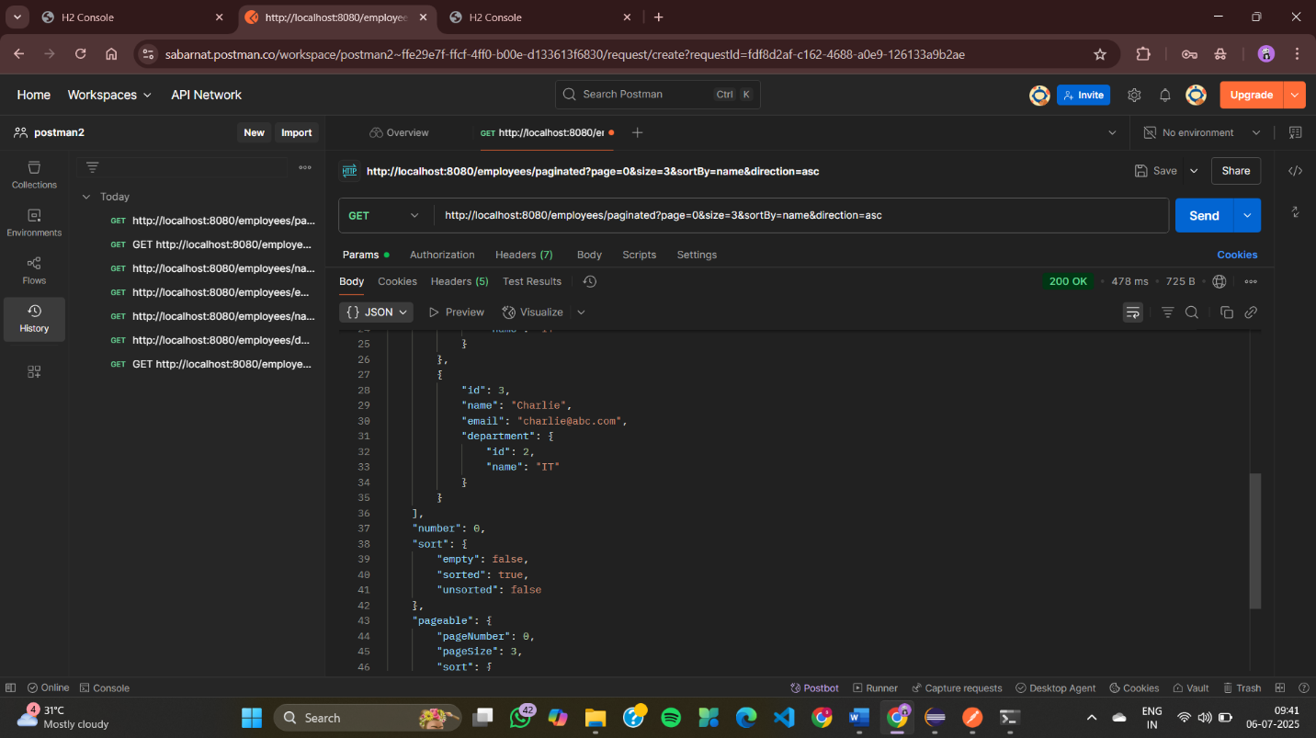

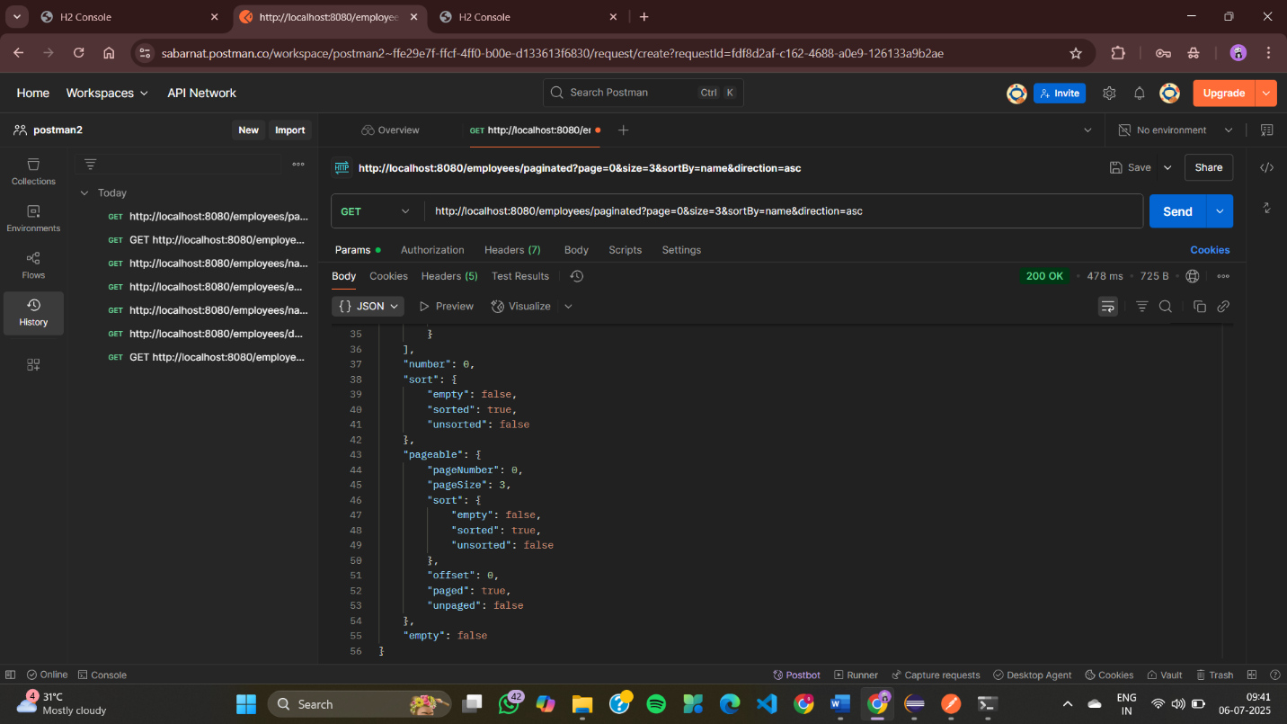

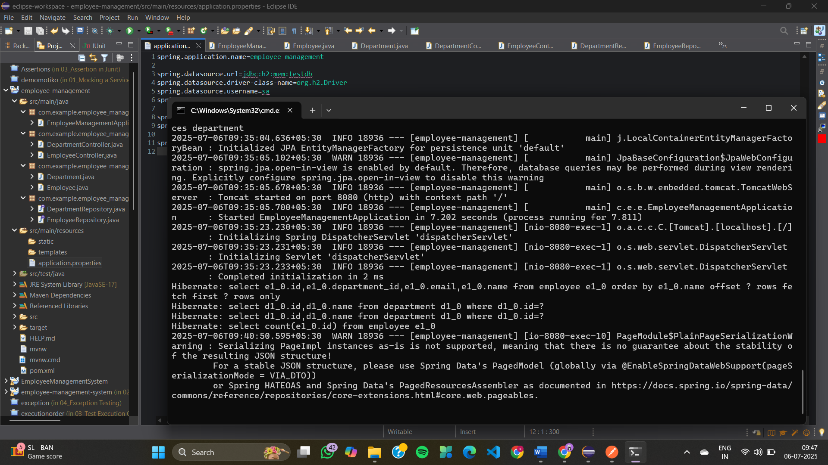

**Exercise 7: Employee Management System - Enabling Entity Auditing**

**AuditorAwareImpl.java**

package com.example.employee_management.config;

import org.springframework.context.annotation.Configuration;

import org.springframework.data.domain.AuditorAware;

import java.util.Optional;

@Configuration

public class AuditorAwareImpl implements AuditorAware<String> {

@Override

public Optional<String> getCurrentAuditor() {

// hardcoded for demo — change to actual user in real apps

return Optional.of("system-user");

}

}

**DepartmentController.java**

package com.example.employee_management.controller;

import com.example.employee_management.entity.Department;

import com.example.employee_management.repository.DepartmentRepository;

import org.springframework.web.bind.annotation.*;

import java.util.List;

@RestController

@RequestMapping("/departments")

public class DepartmentController {

private final DepartmentRepository deptRepo;

public DepartmentController(DepartmentRepository deptRepo) {

this.deptRepo = deptRepo;

}

@GetMapping

public List<Department> getAll() {

return deptRepo.findAll();

}

@GetMapping("/{id}")

public Department getById(@PathVariable Long id) {

return deptRepo.findById(id).orElseThrow();

}

@PostMapping

public Department create(@RequestBody Department dept) {

return deptRepo.save(dept);

}

@PutMapping("/{id}")

public Department update(@PathVariable Long id, @RequestBody Department updatedDept) {

Department dept = deptRepo.findById(id).orElseThrow();

dept.setName(updatedDept.getName());

return deptRepo.save(dept);

}

@DeleteMapping("/{id}")

public void delete(@PathVariable Long id) {

deptRepo.deleteById(id);

}

}

**EmployeeController.java**

package com.example.employee_management.controller;

import com.example.employee_management.entity.Employee;

import com.example.employee_management.repository.EmployeeRepository;

import com.example.employee_management.repository.DepartmentRepository;

import org.springframework.web.bind.annotation.*;

import java.util.List;

@RestController

@RequestMapping("/employees")

public class EmployeeController {

private final EmployeeRepository empRepo;

private final DepartmentRepository deptRepo;

public EmployeeController(EmployeeRepository empRepo, DepartmentRepository deptRepo) {

this.empRepo = empRepo;

this.deptRepo = deptRepo;

}

@GetMapping

public List<Employee> getAll() {

return empRepo.findAll();

}

@GetMapping("/{id}")

public Employee getById(@PathVariable Long id) {

return empRepo.findById(id).orElseThrow();

}

@PostMapping

public Employee create(@RequestBody Employee emp) {

if (emp.getDepartment() != null) {

deptRepo.findById(emp.getDepartment().getId()).orElseThrow();

}

return empRepo.save(emp);

}

@PutMapping("/{id}")

public Employee update(@PathVariable Long id, @RequestBody Employee updatedEmp) {

Employee emp = empRepo.findById(id).orElseThrow();

emp.setName(updatedEmp.getName());

emp.setEmail(updatedEmp.getEmail());

if (updatedEmp.getDepartment() != null) {

deptRepo.findById(updatedEmp.getDepartment().getId()).orElseThrow();

emp.setDepartment(updatedEmp.getDepartment());

}

return empRepo.save(emp);

}

@DeleteMapping("/{id}")

public void delete(@PathVariable Long id) {

empRepo.deleteById(id);

}

}

**Department.java**

package com.example.employee_management.entity;

import jakarta.persistence.*;

import jakarta.persistence.Id;

import org.springframework.data.annotation.*;

import org.springframework.data.jpa.domain.support.AuditingEntityListener;

import java.time.LocalDateTime;

@Entity

@EntityListeners(AuditingEntityListener.class)

public class Department {

@Id

@GeneratedValue(strategy = GenerationType.IDENTITY)

private Long id;

private String name;

@CreatedDate

@Column(updatable = false)

private LocalDateTime createdDate;

@LastModifiedDate

private LocalDateTime lastModifiedDate;

@CreatedBy

private String createdBy;

@LastModifiedBy

private String lastModifiedBy;

public Long getId() { return id; }

public void setId(Long id) { this.id = id; }

public String getName() { return name; }

public void setName(String name) { this.name = name; }

public LocalDateTime getCreatedDate() { return createdDate; }

public void setCreatedDate(LocalDateTime createdDate) { this.createdDate = createdDate; }

public LocalDateTime getLastModifiedDate() { return lastModifiedDate; }

public void setLastModifiedDate(LocalDateTime lastModifiedDate) { this.lastModifiedDate = lastModifiedDate; }

public String getCreatedBy() { return createdBy; }

public void setCreatedBy(String createdBy) { this.createdBy = createdBy; }

public String getLastModifiedBy() { return lastModifiedBy; }

public void setLastModifiedBy(String lastModifiedBy) { this.lastModifiedBy = lastModifiedBy; }

}

**Employee.java**

package com.example.employee_management.entity;

import jakarta.persistence.*;

import jakarta.persistence.Id;

import org.springframework.data.annotation.*;

import org.springframework.data.jpa.domain.support.AuditingEntityListener;

import java.time.LocalDateTime;

@Entity

@EntityListeners(AuditingEntityListener.class)

public class Employee {

@Id

@GeneratedValue(strategy = GenerationType.IDENTITY)

private Long id;

private String name;

private String email;

@ManyToOne

@JoinColumn(name = "department_id")

private Department department;

@CreatedDate

@Column(updatable = false)

private LocalDateTime createdDate;

@LastModifiedDate

private LocalDateTime lastModifiedDate;

@CreatedBy

private String createdBy;

@LastModifiedBy

private String lastModifiedBy;

public Long getId() { return id; }

public void setId(Long id) { this.id = id; }

public String getName() { return name; }

public void setName(String name) { this.name = name; }

public String getEmail() { return email; }

public void setEmail(String email) { this.email = email; }

public Department getDepartment() { return department; }

public void setDepartment(Department department) { this.department = department; }

public LocalDateTime getCreatedDate() { return createdDate; }

public void setCreatedDate(LocalDateTime createdDate) { this.createdDate = createdDate; }

public LocalDateTime getLastModifiedDate() { return lastModifiedDate; }

public void setLastModifiedDate(LocalDateTime lastModifiedDate) { this.lastModifiedDate = lastModifiedDate; }

public String getCreatedBy() { return createdBy; }

public void setCreatedBy(String createdBy) { this.createdBy = createdBy; }

public String getLastModifiedBy() { return lastModifiedBy; }

public void setLastModifiedBy(String lastModifiedBy) { this.lastModifiedBy = lastModifiedBy; }

}

**DepartmentRepository.java**

package com.example.employee_management.repository;

import com.example.employee_management.entity.Department;

import org.springframework.data.jpa.repository.JpaRepository;

public interface DepartmentRepository extends JpaRepository<Department, Long> {

}

**EmployeeRepository.java**

package com.example.employee_management.repository;

import com.example.employee_management.entity.Employee;

import org.springframework.data.jpa.repository.JpaRepository;

public interface EmployeeRepository extends JpaRepository<Employee, Long> {

}

**EmployeeManagementApplication.java**

package com.example.employee_management;

import org.springframework.boot.SpringApplication;

import org.springframework.boot.autoconfigure.SpringBootApplication;

import org.springframework.data.jpa.repository.config.EnableJpaAuditing;

@SpringBootApplication

@EnableJpaAuditing

public class EmployeeManagementApplication {

public static void main(String[] args) {

SpringApplication.run(EmployeeManagementApplication.class, args);

}

}

**application.properties**

spring.application.name=employee-management

spring.datasource.url=jdbc:h2:mem:testdb

spring.datasource.driver-class-name=org.h2.Driver

spring.datasource.username=sa

spring.datasource.password=

spring.jpa.hibernate.ddl-auto=update

spring.jpa.show-sql=true

spring.jpa.properties.hibernate.format_sql=true

spring.h2.console.enabled=true

**EmployeeManagementApplicationTests.java**

package com.example.employee_management;

import org.junit.jupiter.api.Test;

import org.springframework.boot.test.context.SpringBootTest;

@SpringBootTest

class EmployeeManagementApplicationTests {

@Test

void contextLoads() {

}

}

**OUTPUT**

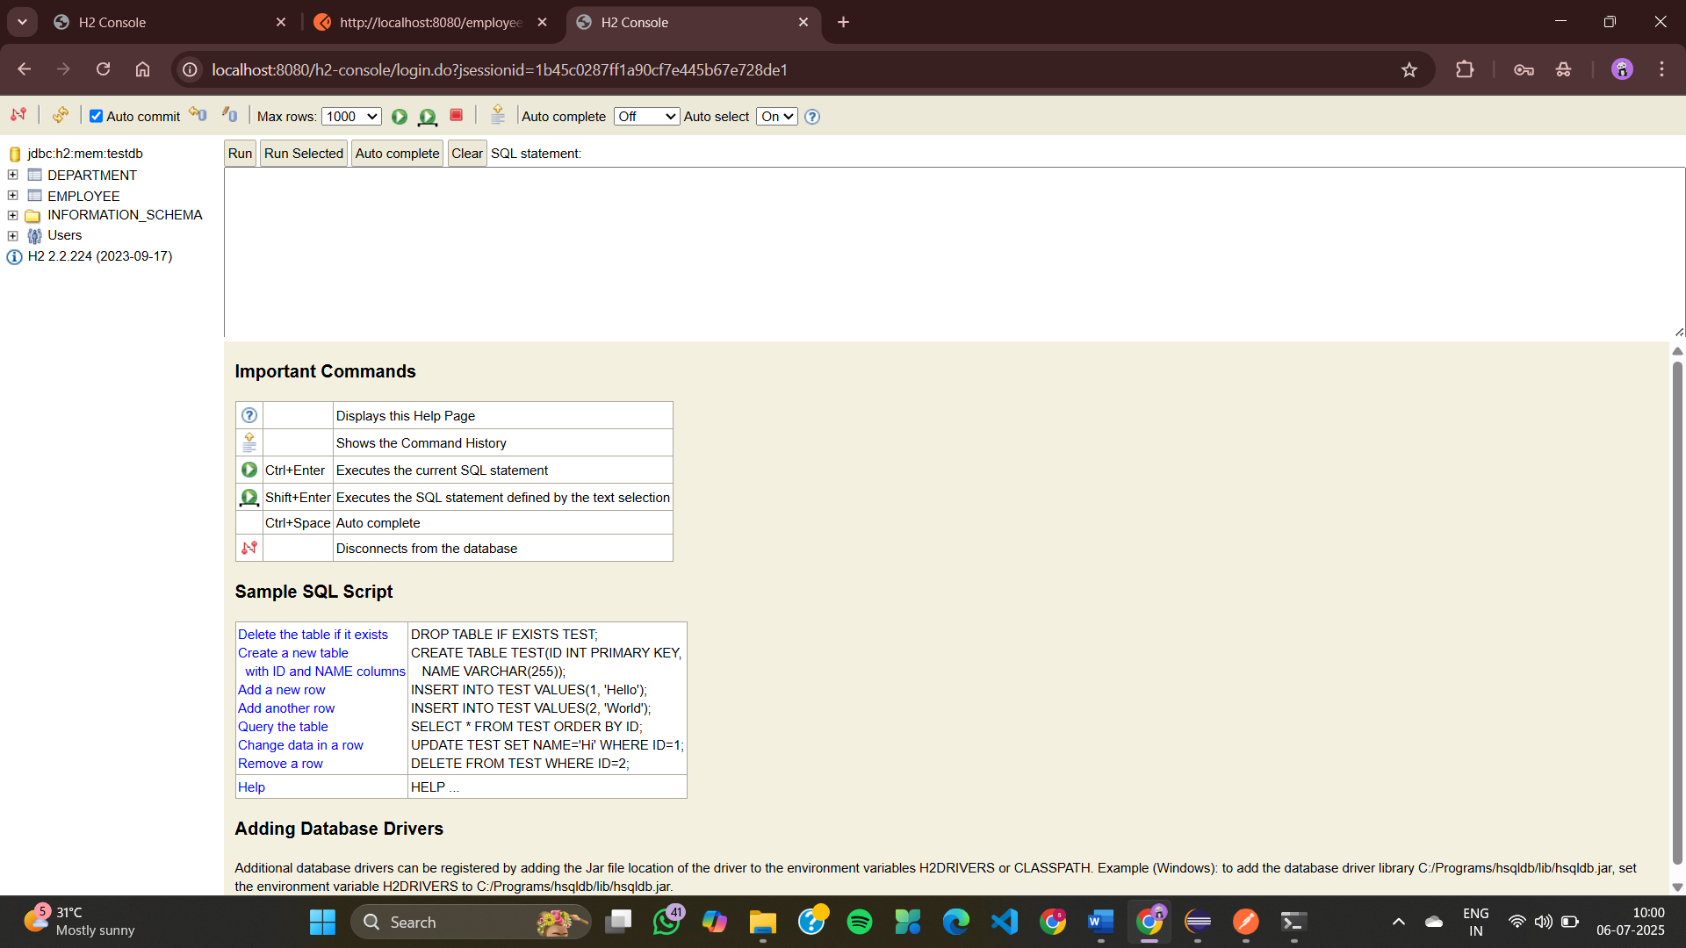

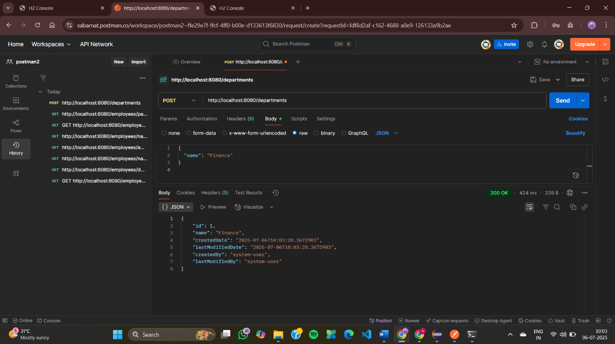

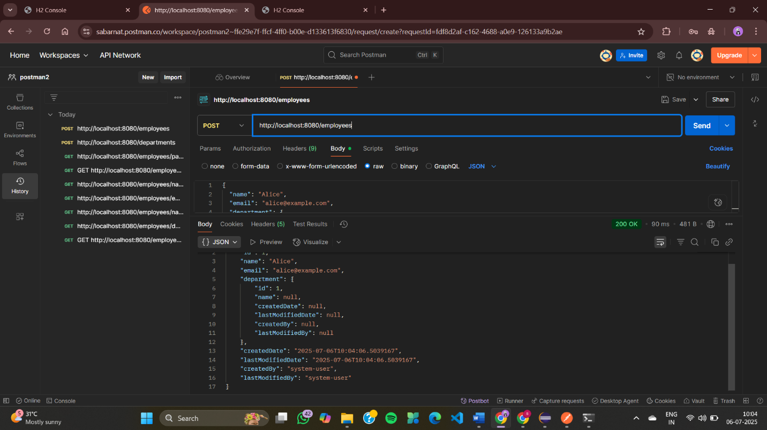

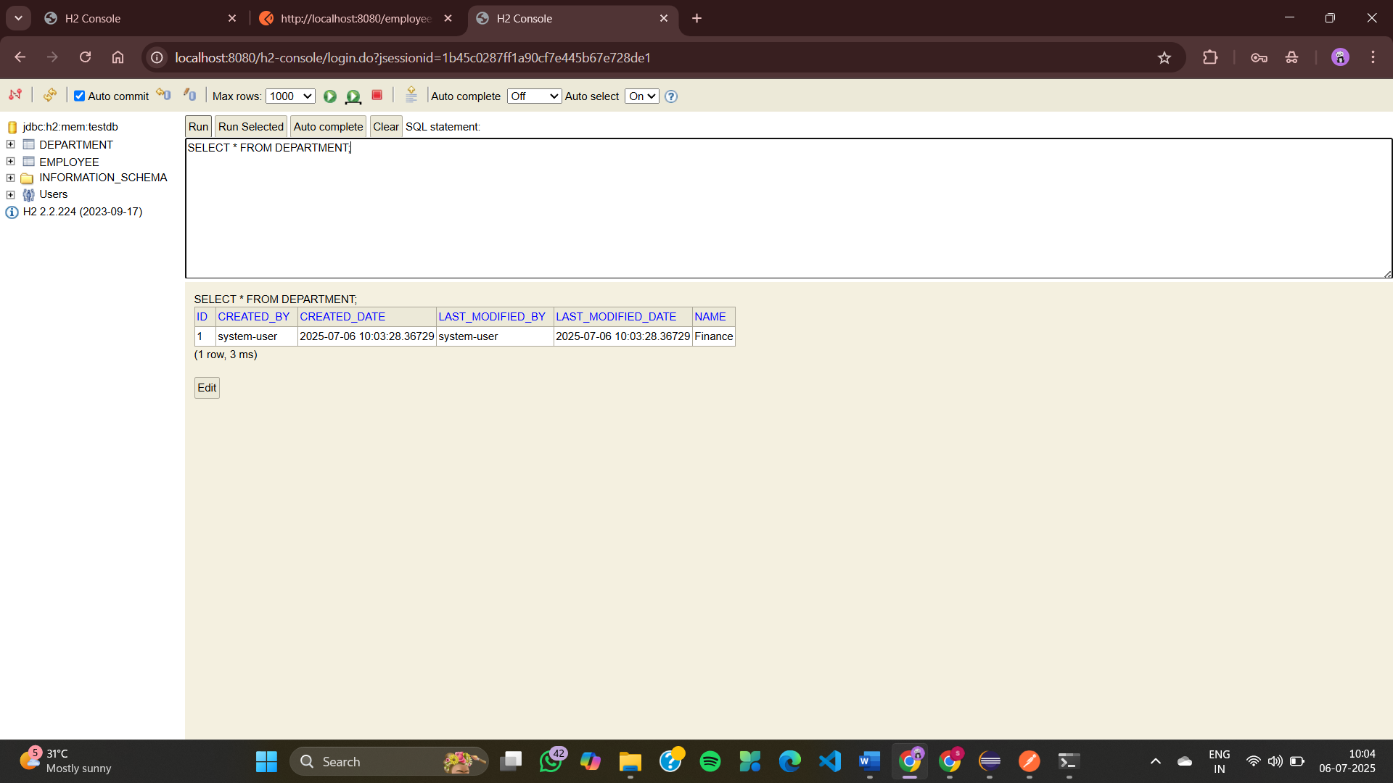

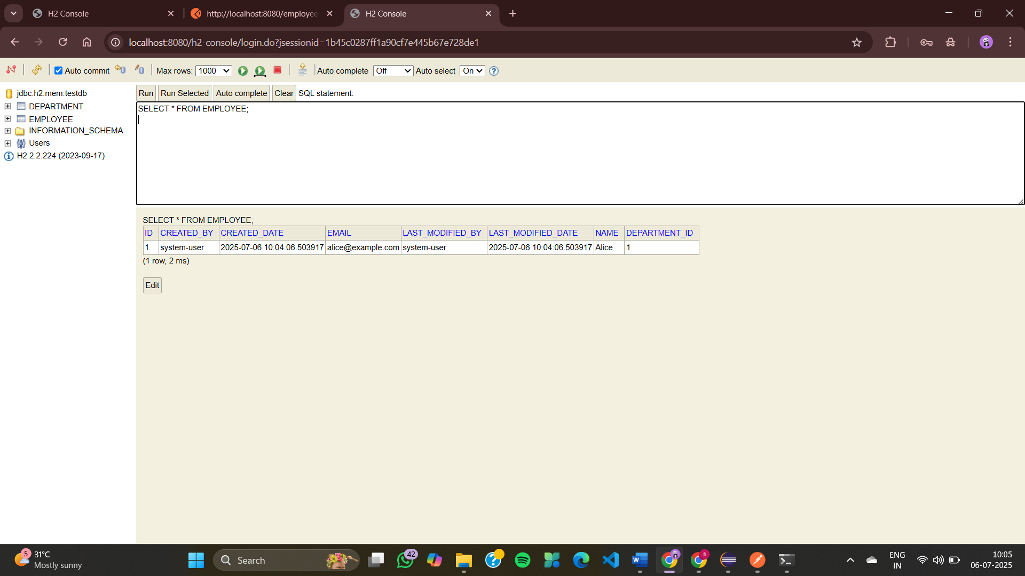

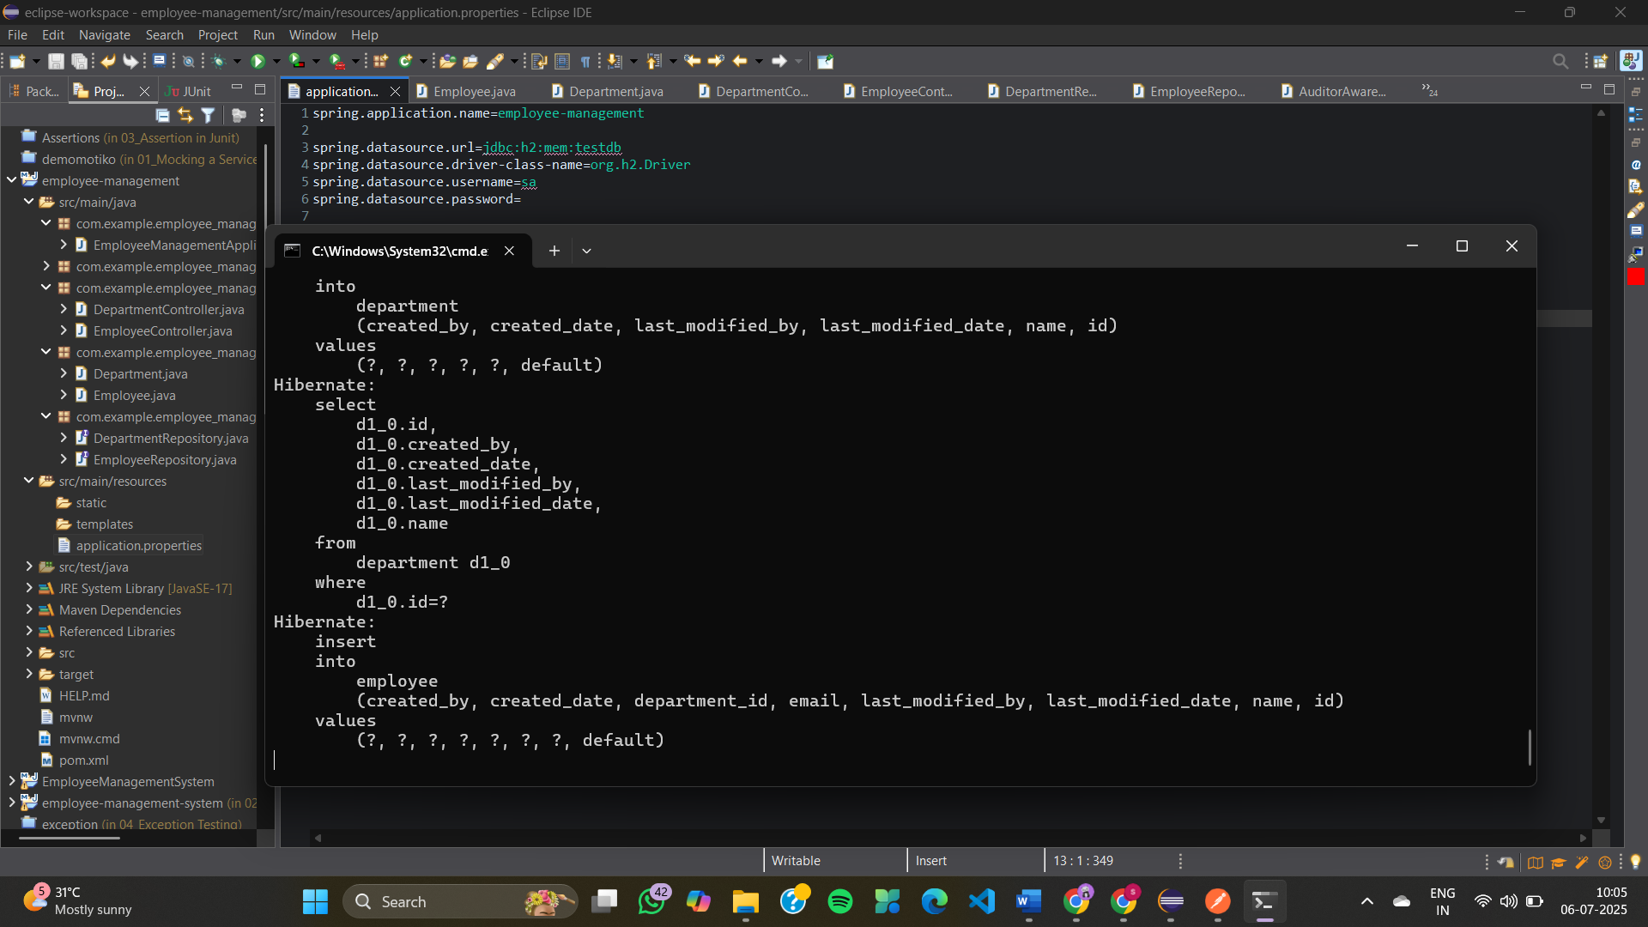

**Exercise 8: Employee Management System - Creating Projections**

**AuditorAwareImpl.java**

package com.example.employee_management.config;

import org.springframework.context.annotation.Configuration;

import org.springframework.data.domain.AuditorAware;

import java.util.Optional;

@Configuration

public class AuditorAwareImpl implements AuditorAware<String> {

@Override

public Optional<String> getCurrentAuditor() {

// hardcoded for demo — change to actual user in real apps

return Optional.of("system-user");

}

}

**DepartmentController.java**

package com.example.employee_management.controller;

import com.example.employee_management.entity.Department;

import com.example.employee_management.repository.DepartmentRepository;

import org.springframework.web.bind.annotation.*;

import java.util.List;

@RestController

@RequestMapping("/departments")

public class DepartmentController {

private final DepartmentRepository deptRepo;

public DepartmentController(DepartmentRepository deptRepo) {

this.deptRepo = deptRepo;

}

@GetMapping

public List<Department> getAll() {

return deptRepo.findAll();

}

@GetMapping("/{id}")

public Department getById(@PathVariable Long id) {

return deptRepo.findById(id).orElseThrow();

}

@PostMapping

public Department create(@RequestBody Department dept) {

return deptRepo.save(dept);

}

@PutMapping("/{id}")

public Department update(@PathVariable Long id, @RequestBody Department updatedDept) {

Department dept = deptRepo.findById(id).orElseThrow();

dept.setName(updatedDept.getName());

return deptRepo.save(dept);

}

@DeleteMapping("/{id}")

public void delete(@PathVariable Long id) {

deptRepo.deleteById(id);

}

}

**EmployeeController.java**

package com.example.employee_management.controller;

import com.example.employee_management.dto.EmployeeDTO;

import com.example.employee_management.entity.Employee;

import com.example.employee_management.projection.EmployeeNameEmailProjection;

import com.example.employee_management.repository.DepartmentRepository;

import com.example.employee_management.repository.EmployeeRepository;

import org.springframework.web.bind.annotation.*;

import java.util.List;

@RestController

@RequestMapping("/employees")

public class EmployeeController {

private final EmployeeRepository empRepo;

private final DepartmentRepository deptRepo;

public EmployeeController(EmployeeRepository empRepo, DepartmentRepository deptRepo) {

this.empRepo = empRepo;

this.deptRepo = deptRepo;

}

@GetMapping

public List<Employee> getAll() {

return empRepo.findAll();

}

@PostMapping

public Employee create(@RequestBody Employee emp) {

if (emp.getDepartment() != null) {

deptRepo.findById(emp.getDepartment().getId()).orElseThrow();

}

return empRepo.save(emp);

}

// Interface-based Projection

@GetMapping("/projection/interface/{deptId}")

public List<EmployeeNameEmailProjection> getEmployeeNamesEmailsByDept(@PathVariable Long deptId) {

return empRepo.findByDepartmentId(deptId);

}

// Class-based Projection

@GetMapping("/projection/class")

public List<EmployeeDTO> getEmployeeDTOs() {

return empRepo.fetchEmployeeWithDeptName();

}

}

**EmployeeDTO.java**

package com.example.employee_management.dto;

public class EmployeeDTO {

private String name;

private String departmentName;

public EmployeeDTO(String name, String departmentName) {

this.name = name;

this.departmentName = departmentName;

}

public String getName() { return name; }

public String getDepartmentName() { return departmentName; }

}

**Department.java**

package com.example.employee_management.entity;

import jakarta.persistence.*;

@Entity

public class Department {

@Id

@GeneratedValue(strategy = GenerationType.IDENTITY)

private Long id;

private String name;

public Long getId() { return id; }

public void setId(Long id) { this.id = id; }

public String getName() { return name; }

public void setName(String name) { this.name = name; }

}

**Employee.java**

package com.example.employee_management.entity;

import jakarta.persistence.*;

@Entity

public class Employee {

@Id

@GeneratedValue(strategy = GenerationType.IDENTITY)

private Long id;

private String name;

private String email;

@ManyToOne

@JoinColumn(name = "department_id")

private Department department;

public Long getId() { return id; }

public void setId(Long id) { this.id = id; }

public String getName() { return name; }

public void setName(String name) { this.name = name; }

public String getEmail() { return email; }

public void setEmail(String email) { this.email = email; }

public Department getDepartment() { return department; }

public void setDepartment(Department department) { this.department = department; }

}

**EmployeeNameEmailProjection.java**

package com.example.employee_management.projection;

public interface EmployeeNameEmailProjection {

String getName();

String getEmail();

}

**DepartmentRepository.java**

package com.example.employee_management.repository;

import com.example.employee_management.entity.Department;

import org.springframework.data.jpa.repository.JpaRepository;

public interface DepartmentRepository extends JpaRepository<Department, Long> {

}

**EmployeeRepository.java**

package com.example.employee_management.repository;

import com.example.employee_management.entity.Employee;

import com.example.employee_management.dto.EmployeeDTO;

import com.example.employee_management.projection.EmployeeNameEmailProjection;

import org.springframework.data.jpa.repository.JpaRepository;

import org.springframework.data.jpa.repository.Query;

import java.util.List;

public interface EmployeeRepository extends JpaRepository<Employee, Long> {

// Interface-based projection

List<EmployeeNameEmailProjection> findByDepartmentId(Long deptId);

// Class-based DTO projection

@Query("SELECT new com.example.employee_management.dto.EmployeeDTO(e.name, e.department.name) FROM Employee e")

List<EmployeeDTO> fetchEmployeeWithDeptName();

}

**EmployeeManagementApplication.java**

package com.example.employee_management;

import org.springframework.boot.SpringApplication;

import org.springframework.boot.autoconfigure.SpringBootApplication;

@SpringBootApplication

public class EmployeeManagementApplication {

public static void main(String[] args) {

SpringApplication.run(EmployeeManagementApplication.class, args);

}

}

**application.properties**

spring.datasource.url=jdbc:h2:mem:testdb

spring.datasource.driver-class-name=org.h2.Driver

spring.datasource.username=sa

spring.datasource.password=

spring.jpa.hibernate.ddl-auto=update

spring.jpa.show-sql=true

spring.h2.console.enabled=true

**EmployeeManagementApplicationTests.java**

package com.example.employee_management;

import org.junit.jupiter.api.Test;

import org.springframework.boot.test.context.SpringBootTest;

@SpringBootTest

class EmployeeManagementApplicationTests {

@Test

void contextLoads() {

}

}

**OUTPUT**

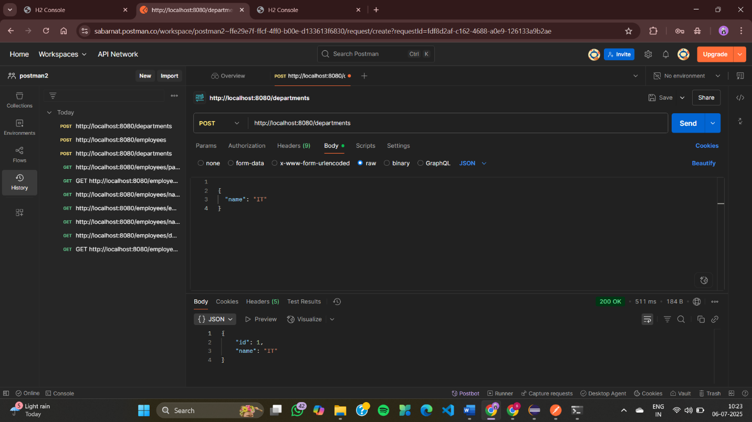

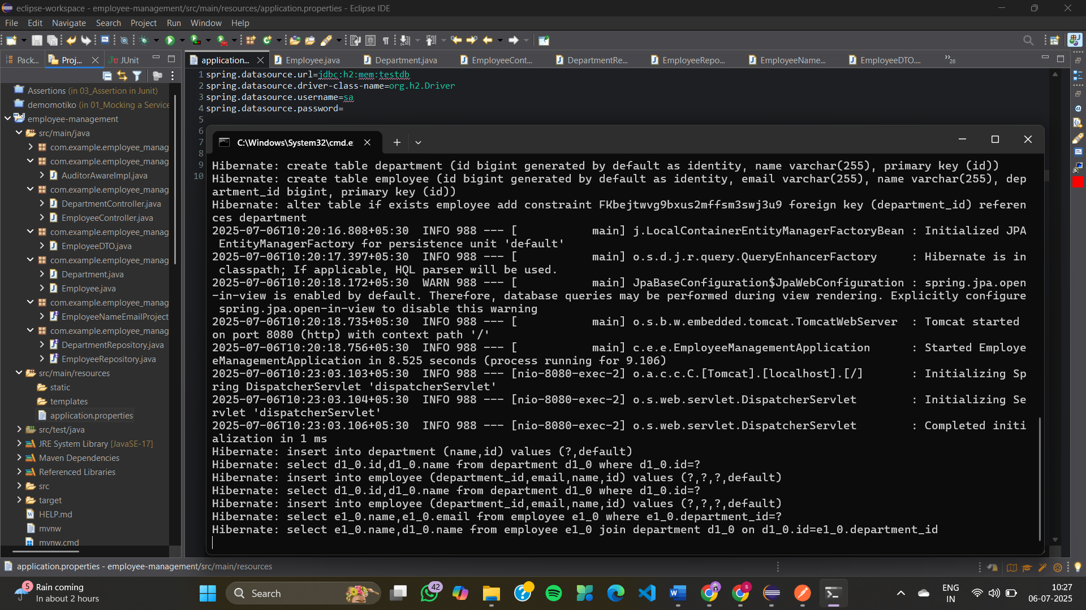

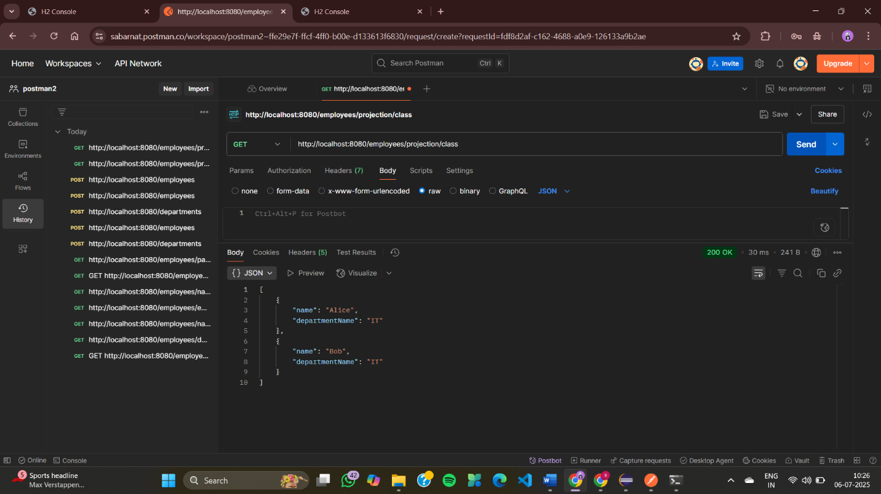

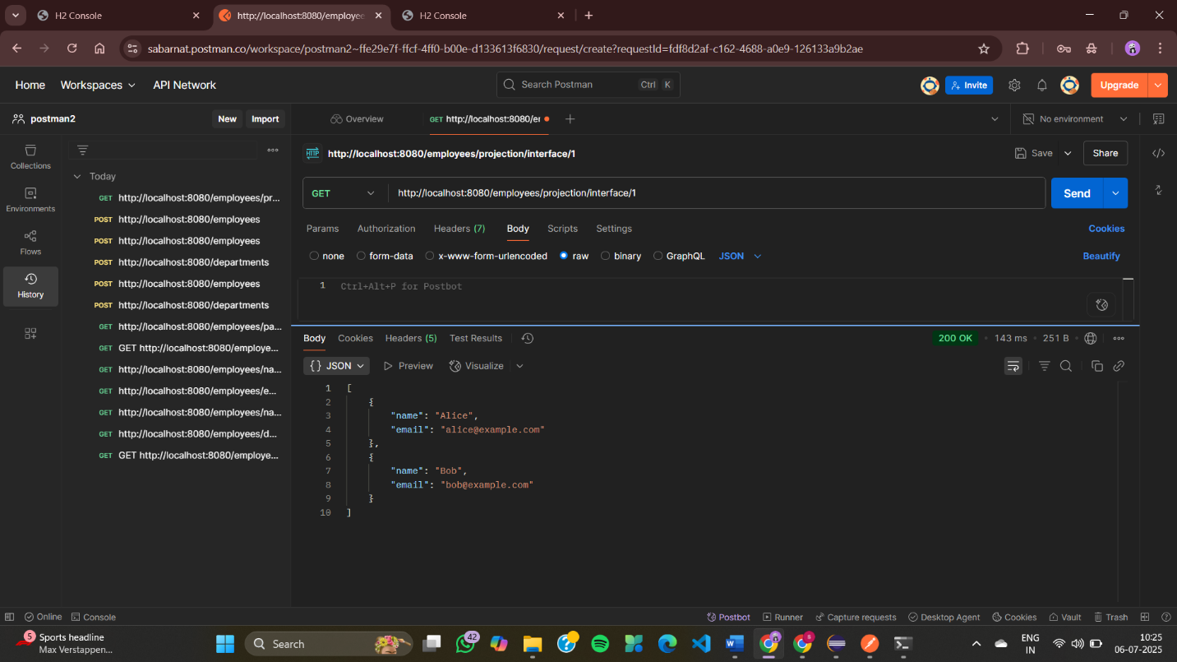

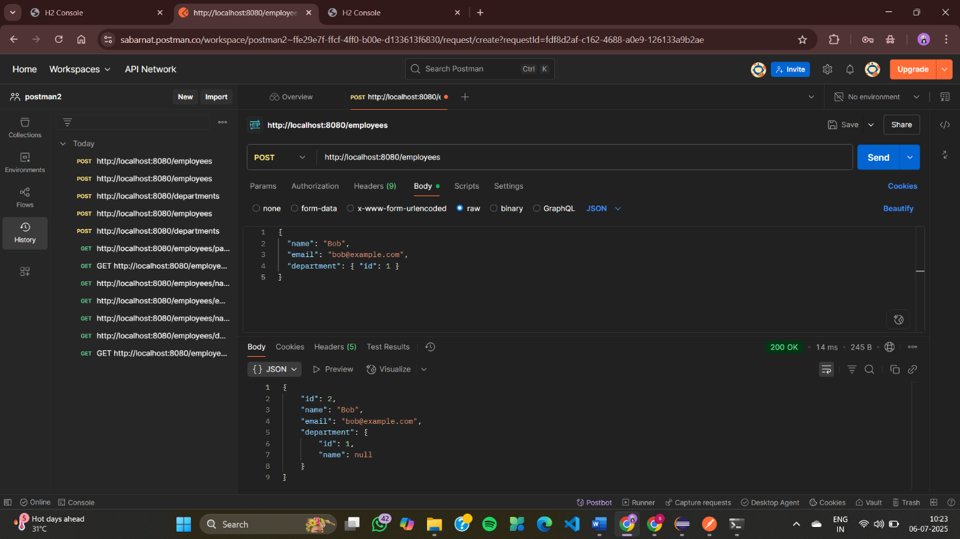

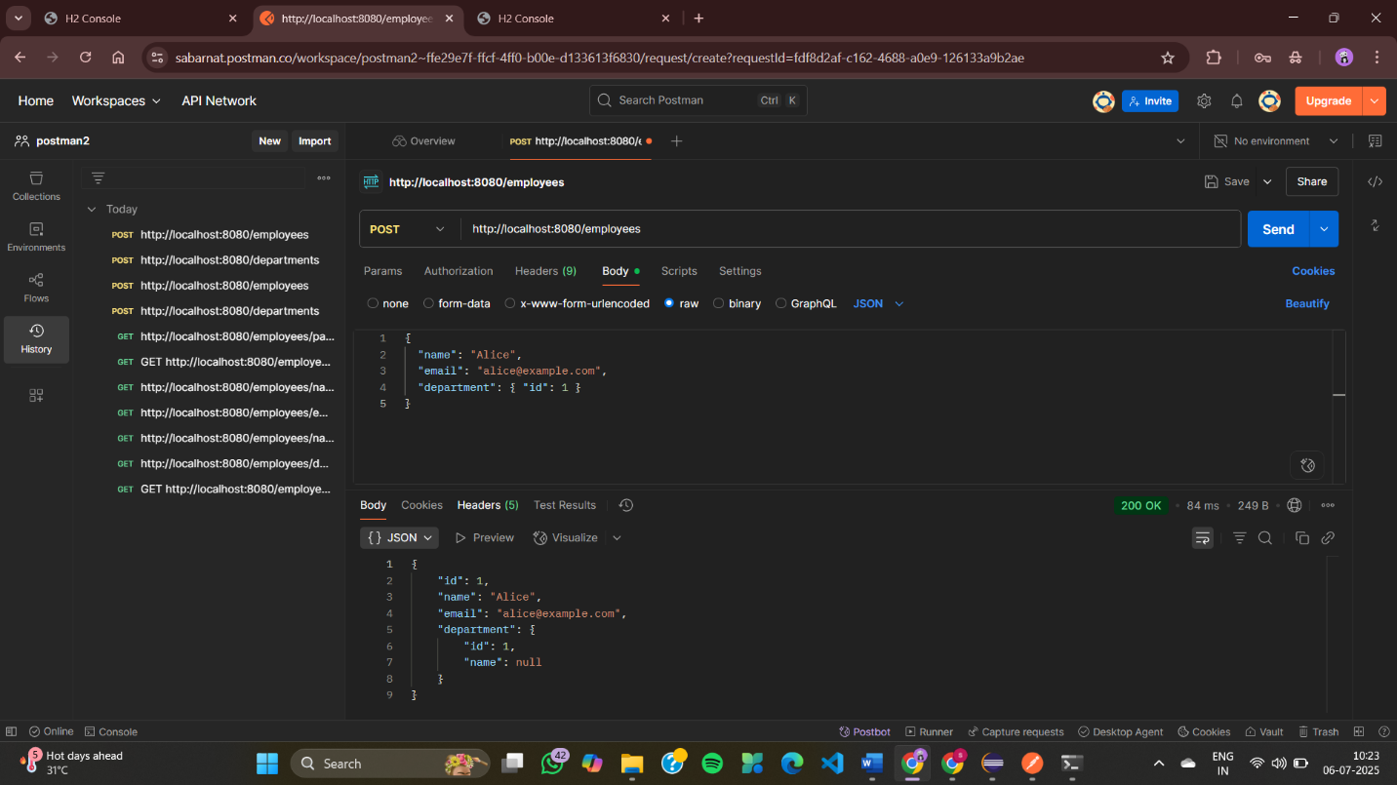

**Exercise 9: Employee Management System - Customizing Data Source Configuration**

**EmployeeManagementSystemEx9Application.java**

package com.example.EmployeeManagementSystem;

import org.springframework.boot.SpringApplication;

import org.springframework.boot.autoconfigure.SpringBootApplication;

@SpringBootApplication(scanBasePackages = "com.example")

public class EmployeeManagementSystemEx9Application {

public static void main(String[] args) {

SpringApplication.run(EmployeeManagementSystemEx9Application.class, args);

}

}

**PrimaryDataSourceConfig.java**

package com.example.config;

import jakarta.persistence.EntityManagerFactory;

import org.springframework.beans.factory.annotation.Qualifier;

import org.springframework.boot.autoconfigure.jdbc.DataSourceProperties;

import org.springframework.boot.context.properties.ConfigurationProperties;

import org.springframework.context.annotation.*;

import org.springframework.boot.orm.jpa.EntityManagerFactoryBuilder;

import org.springframework.data.jpa.repository.config.EnableJpaRepositories;

import org.springframework.jdbc.datasource.lookup.JndiDataSourceLookup;

import org.springframework.orm.jpa.JpaTransactionManager;

import org.springframework.orm.jpa.LocalContainerEntityManagerFactoryBean;

import org.springframework.orm.jpa.vendor.HibernateJpaVendorAdapter;

import org.springframework.transaction.PlatformTransactionManager;

import org.springframework.transaction.annotation.EnableTransactionManagement;

import javax.sql.DataSource;

@Configuration

@EnableTransactionManagement

@EnableJpaRepositories(

basePackages = "com.example.primary.repository",

entityManagerFactoryRef = "primaryEntityManagerFactory",

transactionManagerRef = "primaryTransactionManager"

)

public class PrimaryDataSourceConfig {

@Primary

@Bean

@ConfigurationProperties("spring.datasource")

public DataSourceProperties primaryDataSourceProperties() {

return new DataSourceProperties();

}

@Primary

@Bean

public DataSource primaryDataSource() {

return primaryDataSourceProperties().initializeDataSourceBuilder().build();

}

@Primary

@Bean

public LocalContainerEntityManagerFactoryBean primaryEntityManagerFactory(

EntityManagerFactoryBuilder builder) {

return builder

.dataSource(primaryDataSource())

.packages("com.example.primary.model")

.persistenceUnit("primary")

.build();

}

@Primary

@Bean

public PlatformTransactionManager primaryTransactionManager(

@Qualifier("primaryEntityManagerFactory") EntityManagerFactory emf) {

return new JpaTransactionManager(emf);

}

}

**SecondaryDataSourceConfig.java**

package com.example.config;

import jakarta.persistence.EntityManagerFactory;

import org.springframework.beans.factory.annotation.Qualifier;

import org.springframework.boot.autoconfigure.jdbc.DataSourceProperties;

import org.springframework.boot.context.properties.ConfigurationProperties;

import org.springframework.context.annotation.*;

import org.springframework.boot.orm.jpa.EntityManagerFactoryBuilder;

import org.springframework.data.jpa.repository.config.EnableJpaRepositories;

import org.springframework.orm.jpa.JpaTransactionManager;

import org.springframework.orm.jpa.LocalContainerEntityManagerFactoryBean;

import org.springframework.orm.jpa.vendor.HibernateJpaVendorAdapter;

import org.springframework.transaction.PlatformTransactionManager;

import org.springframework.transaction.annotation.EnableTransactionManagement;

import javax.sql.DataSource;

@Configuration

@EnableTransactionManagement

@EnableJpaRepositories(

basePackages = "com.example.secondary.repository",

entityManagerFactoryRef = "secondaryEntityManagerFactory",

transactionManagerRef = "secondaryTransactionManager"

)

public class SecondaryDataSourceConfig {

@Bean

@ConfigurationProperties("spring.secondary.datasource")

public DataSourceProperties secondaryDataSourceProperties() {

return new DataSourceProperties();

}

@Bean

public DataSource secondaryDataSource() {

return secondaryDataSourceProperties().initializeDataSourceBuilder().build();

}

@Bean

public LocalContainerEntityManagerFactoryBean secondaryEntityManagerFactory(

EntityManagerFactoryBuilder builder) {

return builder

.dataSource(secondaryDataSource())

.packages("com.example.secondary.model") // secondary entity package

.persistenceUnit("secondary")

.build();

}

@Bean

public PlatformTransactionManager secondaryTransactionManager(

@Qualifier("secondaryEntityManagerFactory") EntityManagerFactory emf) {

return new JpaTransactionManager(emf);

}

}

**EmployeeController.java**

package com.example.controller;

import com.example.primary.model.Employee;

import com.example.primary.repository.EmployeeRepository;

import com.example.secondary.model.AuditLog;

import com.example.secondary.repository.AuditLogRepository;

import org.springframework.beans.factory.annotation.Autowired;

import org.springframework.web.bind.annotation.*;

import java.time.LocalDateTime;

import java.util.List;

@RestController

@RequestMapping("/employees")

public class EmployeeController {

@Autowired

private EmployeeRepository employeeRepository;

@Autowired

private AuditLogRepository auditLogRepository;

@PostMapping

public Employee createEmployee(@RequestBody Employee employee) {

return employeeRepository.save(employee);

}

@GetMapping("/names")

public List<String> getEmployeeNames() {

return employeeRepository.findAll()

.stream()

.map(Employee::getName)

.toList();

}

@PostMapping("/log")

public String saveLog(@RequestParam String action) {

AuditLog log = new AuditLog();

log.setAction(action);

log.setTimestamp(LocalDateTime.now());

auditLogRepository.save(log);

return "Logged: " + action;

}

}

**Department.java**

package com.example.primary.model;

import jakarta.persistence.*;

@Entity

public class Department {

@Id

@GeneratedValue(strategy = GenerationType.IDENTITY)

private Long id;

private String name;

}

**Employee.java**

package com.example.primary.model;

import jakarta.persistence.*;

@Entity

public class Employee {

@Id

@GeneratedValue(strategy = GenerationType.IDENTITY)

private Long id;

private String name;

private String email;

@ManyToOne

private Department department;

public String getName() { return name; }

public void setName(String name) { this.name = name; }

public Long getId() { return id; }

public void setId(Long id) { this.id = id; }

public String getEmail() { return email; }

public void setEmail(String email) { this.email = email; }

public Department getDepartment() { return department; }

public void setDepartment(Department department) { this.department = department; }

}

**DepartmentRepository.java**

package com.example.primary.repository;

import com.example.primary.model.Department;

import org.springframework.data.jpa.repository.JpaRepository;

public interface DepartmentRepository extends JpaRepository<Department, Long> {

}

**EmployeeRepository.java**

package com.example.primary.repository;

import com.example.primary.model.Employee;

import org.springframework.data.jpa.repository.JpaRepository;

public interface EmployeeRepository extends JpaRepository<Employee, Long> {

}

**AuditLog.java**

package com.example.secondary.model;

import jakarta.persistence.*;

import java.time.LocalDateTime;

@Entity

public class AuditLog {

@Id

@GeneratedValue(strategy = GenerationType.IDENTITY)

private Long id;

private String action;

private LocalDateTime timestamp;

public Long getId() {

return id;

}

public String getAction() {

return action;

}

public LocalDateTime getTimestamp() {

return timestamp;

}

public void setId(Long id) {

this.id = id;

}

public void setAction(String action) {

this.action = action;

}

public void setTimestamp(LocalDateTime timestamp) {

this.timestamp = timestamp;

}

}

**AuditLogRepository.java**

package com.example.secondary.repository;

import com.example.secondary.model.AuditLog;

import org.springframework.data.jpa.repository.JpaRepository;

public interface AuditLogRepository extends JpaRepository<AuditLog, Long> {

}

**application.properties**

# PRIMARY DB (MySQL)

spring.datasource.url=jdbc:mysql://localhost:3306/employeedb

spring.datasource.username=root

spring.datasource.password=gopikA

spring.datasource.driver-class-name=com.mysql.cj.jdbc.Driver

# SECONDARY DB (H2)

spring.second-datasource.url=jdbc:h2:mem:auditdb

spring.second-datasource.driver-class-name=org.h2.Driver

spring.second-datasource.username=sa

spring.second-datasource.password=

# Enable H2 Console

spring.h2.console.enabled=true

spring.h2.console.path=/h2-console

# JPA settings

spring.jpa.hibernate.ddl-auto=update

**EmployeeManagementSystemEx9ApplicationTests.java**

package com.example.EmployeeManagementSystem;

import org.junit.jupiter.api.Test;

import org.springframework.boot.test.context.SpringBootTest;

@SpringBootTest

class EmployeeManagementSystemEx9ApplicationTests {

@Test

void contextLoads() {

}

}

**OUTPUT**

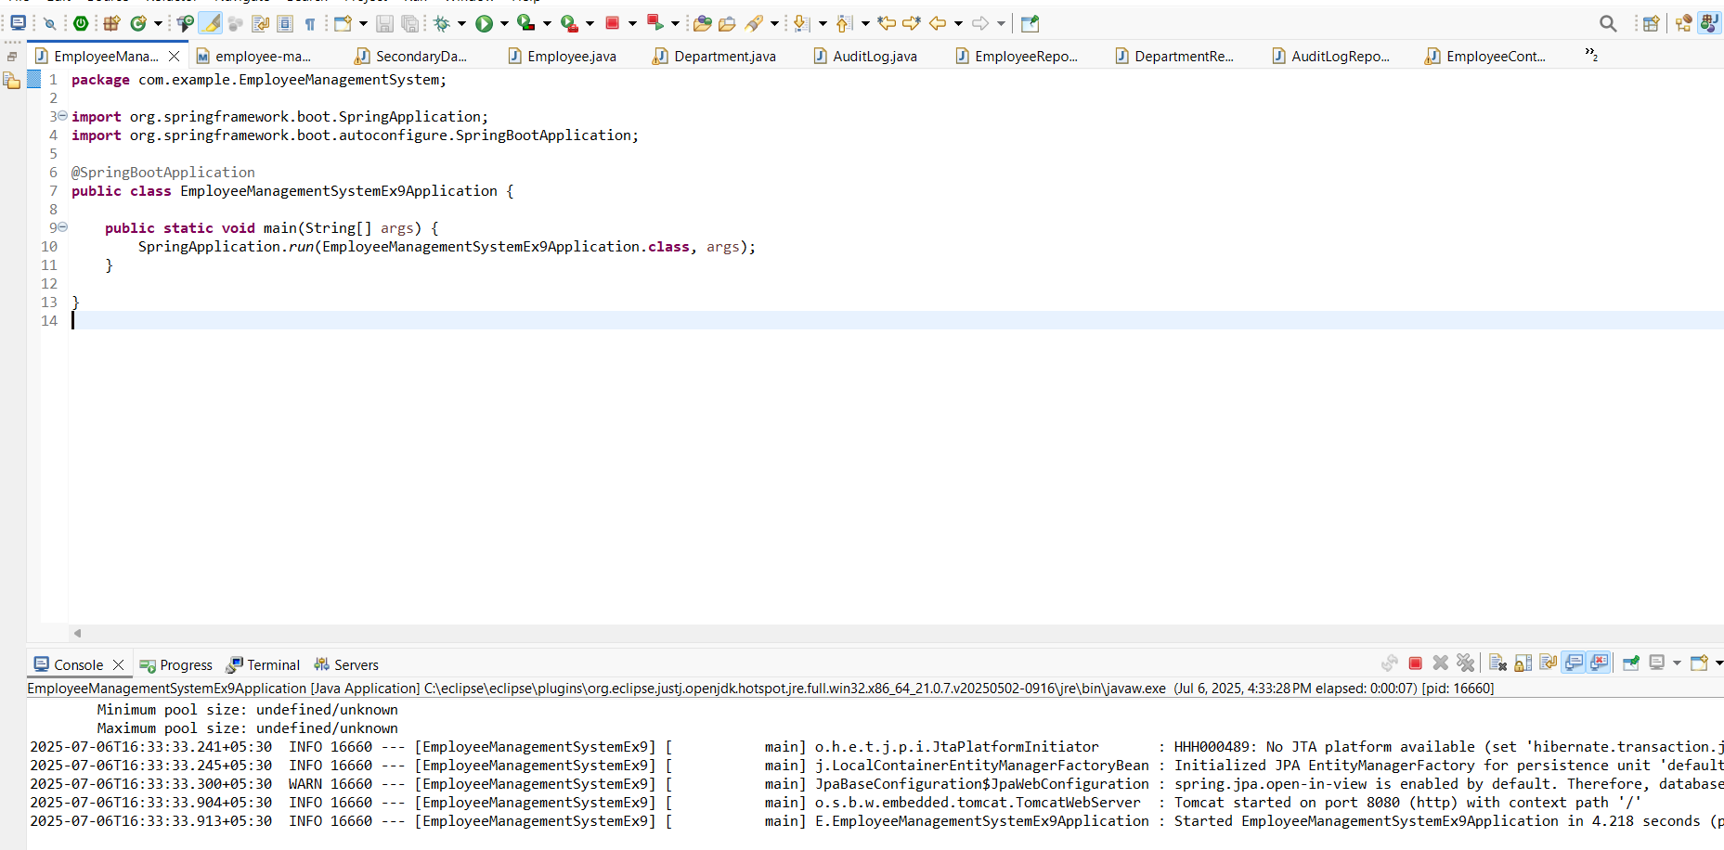

**Exercise 10: Employee Management System - Hibernate-Specific Features**

**BatchController.java**

package com.example.employeemanagement.controller;

import com.example.employeemanagement.entity.Employee;

import com.example.employeemanagement.service.EmployeeBatchService;

import org.springframework.beans.factory.annotation.Autowired;

import org.springframework.web.bind.annotation.*;

import java.util.ArrayList;

import java.util.List;

@RestController

@RequestMapping("/batch")

public class BatchController {

@Autowired

private EmployeeBatchService batchService;

@PostMapping("/employees/{count}")

public String createBulkEmployees(@PathVariable("count") int count) {

List<Employee> list = new ArrayList<>();

for (int i = 1; i <= count; i++) {

Employee e = new Employee();

e.setName("Emp-" + i);

e.setEmail("emp" + i + "@example.com");

e.setDepartment(i % 2 == 0 ? "IT" : "HR");

e.setAttributesJson("{"index":" + i + "}");

list.add(e);

}

batchService.saveEmployeesInBatch(list, 30);

return "Inserted " + count + " employees in batch";

}

}

**Employee.java**

package com.example.employeemanagement.entity;

import jakarta.persistence.*;

import lombok.*;

import org.hibernate.annotations.BatchSize;

import org.hibernate.annotations.DynamicUpdate;

import org.hibernate.annotations.GenericGenerator;

import org.hibernate.annotations.Type;

@Entity

@Data

@NoArgsConstructor

@AllArgsConstructor

@DynamicUpdate // Only changed columns in UPDATE

@BatchSize(size = 30) // Fetch batching for collections

public class Employee {

@Id

@GeneratedValue(strategy = GenerationType.IDENTITY)

private Long id;

private String name;

private String email;

@Column(columnDefinition = "varchar(255)")

private String department;

// Example JSON field stored as text; requires hibernate-types lib

@Type(org.hibernate.type.TextType.class)

@Column(columnDefinition = "clob")

private String attributesJson; // e.g. {"skill":"Java","level":5}

}

**EmployeeRepository.java**

package com.example.employeemanagement.repository;

import com.example.employeemanagement.entity.Employee;

import org.springframework.data.jpa.repository.JpaRepository;

public interface EmployeeRepository extends JpaRepository<Employee, Long> {

}

**EmployeeBatchService.java**

package com.example.employeemanagement.service;

import com.example.employeemanagement.entity.Employee;

import jakarta.persistence.EntityManager;

import jakarta.persistence.PersistenceContext;

import org.springframework.stereotype.Service;

import org.springframework.transaction.annotation.Transactional;

import java.util.List;

@Service

public class EmployeeBatchService {

@PersistenceContext

private EntityManager em;

/**

* Persist employees in batches for performance.

*/

@Transactional

public void saveEmployeesInBatch(List<Employee> employees, int batchSize) {

for (int i = 0; i < employees.size(); i++) {

em.persist(employees.get(i));

if (i % batchSize == 0 && i > 0) {

em.flush();

em.clear(); // free memory

}

}

}

}

**EmployeeManagementSystemApplication.java**

package com.example.employeemanagement;

import org.springframework.boot.SpringApplication;

import org.springframework.boot.autoconfigure.SpringBootApplication;

@SpringBootApplication

public class EmployeeManagementSystemApplication {

public static void main(String[] args) {

SpringApplication.run(EmployeeManagementSystemApplication.class, args);

}

}

**application.properties**

# DataSource (H2)

spring.datasource.url=jdbc:h2:mem:ems_db

spring.datasource.driverClassName=org.h2.Driver

spring.datasource.username=sa

# Hibernate Dialect & Batch settings

spring.jpa.properties.hibernate.dialect=org.hibernate.dialect.H2Dialect

spring.jpa.properties.hibernate.jdbc.batch_size=30

spring.jpa.properties.hibernate.order_inserts=true

spring.jpa.properties.hibernate.order_updates=true

spring.jpa.properties.hibernate.batch_versioned_data=true

spring.jpa.properties.hibernate.generate_statistics=true

spring.jpa.hibernate.ddl-auto=update

spring.jpa.show-sql=true

# Enable H2 console

spring.h2.console.enabled=true

**OUTPUT**

